**THE USE OF FREE WRITING TECHNIQUE IN IMPROVING STUDENTS’ WRITING ABILITY AT TENTH GRADE STUDENTS OF MADRASAH ALIYAH SWASTA ALKHAIRAAT MANADO**

**COVER**

**THESIS**

Submitted as Partial Requirement for the Degree of Education (S.Pd)

in Teaching English



**By:**

**Anggriyani**

**NIM: 1826008**

**ENGLISH EDUCATION STUDY PROGRAM**

**FACULTY OF TARBIYAH AND TEACHER TRAINING**

**MANADO STATE OF INSTITUTE OF ISLAMIC STUDIES**

**1446 H/2025 M**

**THESIS RATIFICATION**

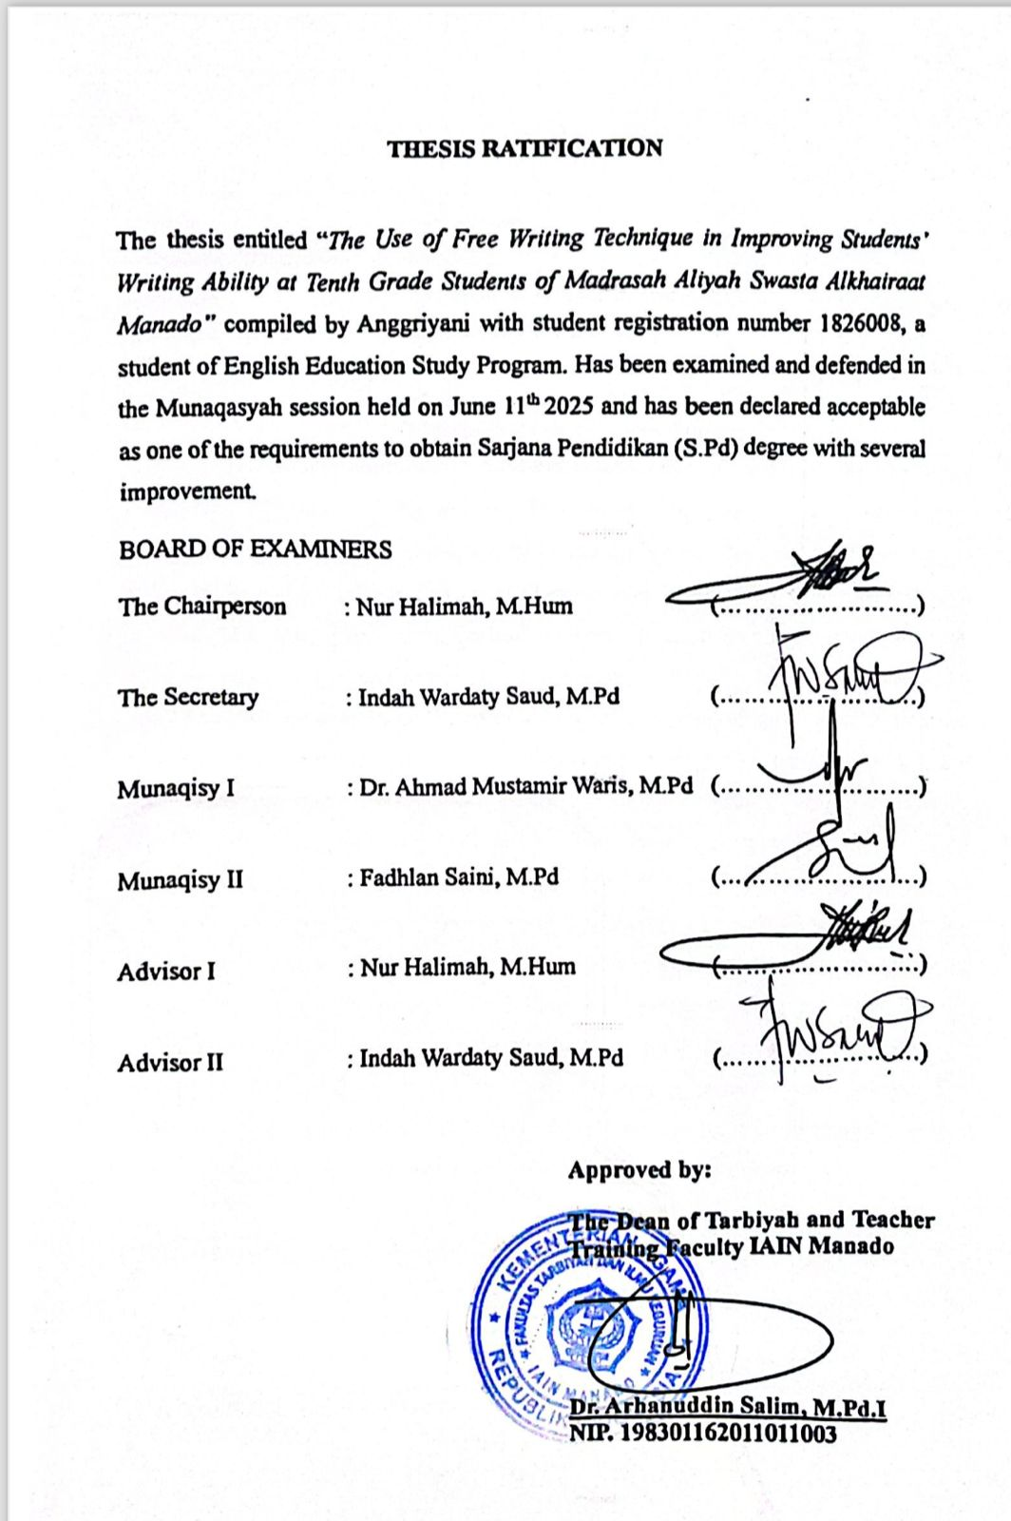

**ABSTRACT**

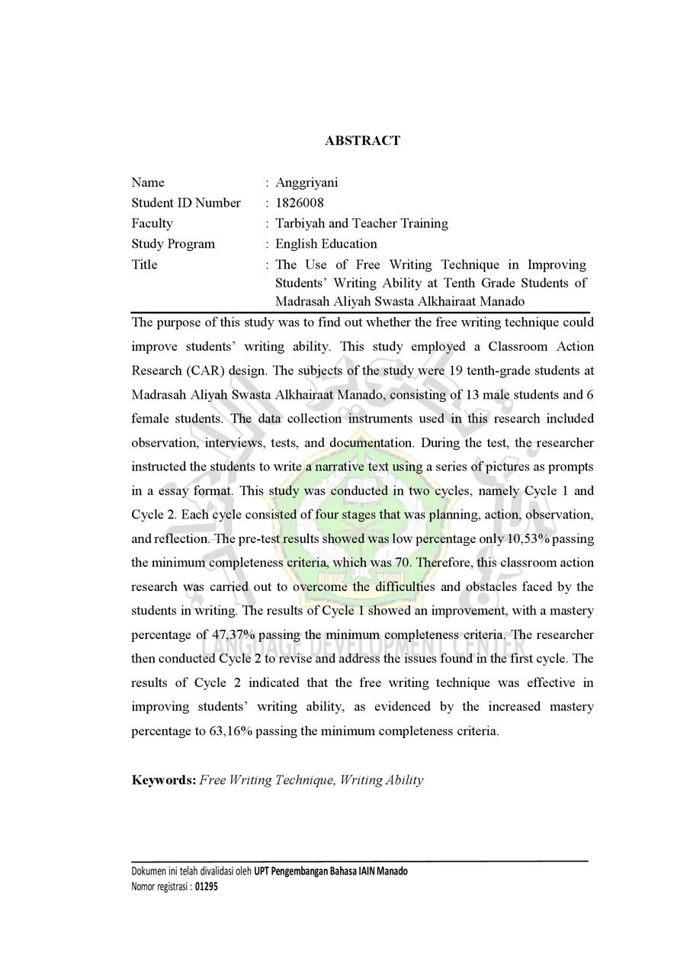

**ABSTRAK**

Nama : Anggriyani

NIM : 1826008

Fakultas : Tarbiyah dan Ilmu Keguruan

Program Studi : Tadris Bahasa Inggris

Judul : Penggunaan Teknik Menulis Bebas dalam Meningkatkan Kemampuan Menulis Siswa pada Siswa Kelas Sepuluh di Madrasah Aliyah Swasta Alkhairaat Manado

Penelitian ini bertujuan untuk mengetahui apakah teknik menulis bebas dapat meningkatkan kemampuan menulis siswa. Penelitian ini menggunakan desain Penelitian Tindakan Kelas (PTK). Subjek penelitian ini adalah 19 siswa kelas sepuluh di Madrasah Aliyah Swasta Alkhairaat Manado, yang terdiri dari 13 siswa laki-laki dan 6 siswa perempuan. Instrumen pengumpulan data yang digunakan dalam penelitian ini meliputi observasi, wawancara, tes, dan dokumentasi. Selama tes, peneliti menginstruksikan siswa untuk menulis teks naratif menggunakan serangkaian gambar sebagai petunjuk dalam format esai. Studi ini dilakukan dalam dua siklus, yaitu Siklus 1 dan Siklus 2. Setiap siklus terdiri dari empat tahap yaitu perencanaan, tindakan, observasi, dan refleksi. Hasil pre-test menunjukkan persentase yang rendah, hanya 10,53% yang memenuhi kriteria ketuntasan minimum, yaitu 70. Oleh karena itu, penelitian tindakan kelas ini dilakukan untuk mengatasi kesulitan dan hambatan yang dihadapi oleh siswa dalam menulis. Hasil Siklus 1 menunjukkan perbaikan, dengan persentase penguasaan sebesar 47,37% yang memenuhi kriteria ketuntasan minimum. Peneliti kemudian melaksanakan Siklus 2 untuk merevisi dan mengatasi masalah yang ditemukan pada siklus pertama. Hasil Siklus 2 menunjukkan bahwa teknik menulis bebas efektif dalam meningkatkan kemampuan menulis siswa, yang dibuktikan dengan peningkatan persentase penguasaan menjadi 63,16% yang memenuhi kriteria ketuntasan minimum.

**Kata Kunci: Teknik Menulis Bebas, Kemampuan Menulis**

**STATEMENT OF AUTHORSHIP**

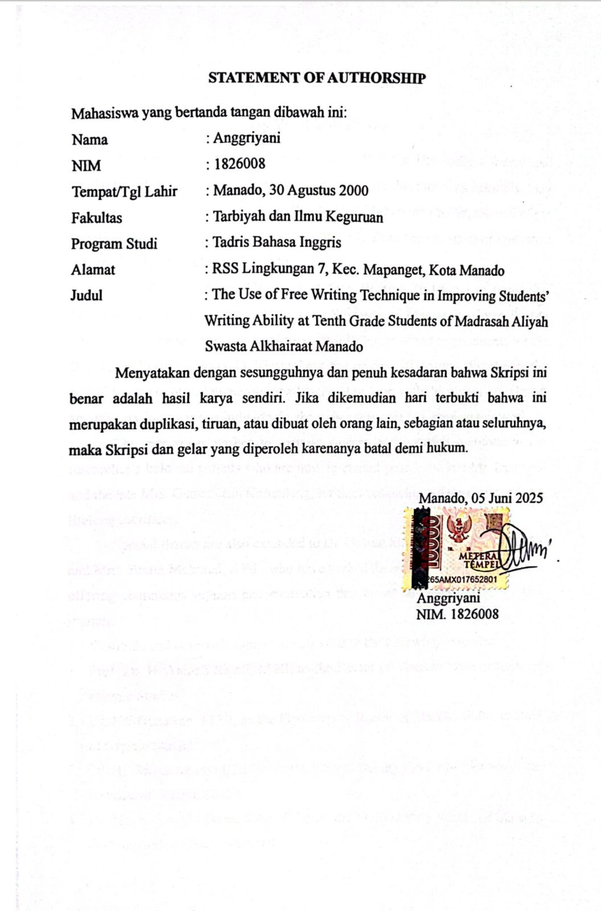

**ACKNOWLEDGEMENT**

بِسْمِ اللهِ الرَّحْمَنِ الرَّحِيْمِ

All praise and gratitude be to Allah SWT for His endless mercy and guidance, which have enabled the writer to complete this thesis successfully. May peace and blessings always be upon the Prophet Muhammad SAW, the seal of the prophets and messengers, who brought humanity from the darkness of ignorance into the light of knowledge and truth.

This thesis, entitled “The Use of Free Writing Technique in Improving Students' Writing Ability at Tenth Grade Students of Madrasah Aliyah Swasta Alkhairaat Manado,” is submitted in partial fulfillment of the requirements for the Bachelor's Degree (Strata 1). Throughout the process of writing this thesis, the researcher encountered numerous challenges. However, with the support, guidance, and prayers from various individuals, the writer was able to complete this work.

The researcher wishes to express sincere and heartfelt gratitude to the researcher’s beloved parents who are now in eternal peace, the late Mr. Djanning and the late Mrs. Gamar Jean Karundeng, for their unconditional love, prayers, and lifelong sacrifices.

Special thanks are also extended to Dr. Usman Musa Sjahrain, S.Pd., M.Si. and Mrs. Yunita Mahmud, S.Pd., who have treated the writer like their own child, offering continuous support and motivation that meant so much throughout this journey.

Gratitude and acknowledgment are also due to the following individuals:

1. Prof. Dr. H. Ahmad Rajafi, M.HI, as the Rector of Manado State Institute of Islamic Studies.
2. Dr. Edi Gunawan, M.HI, as the First Deputy Rector of Manado State Institute of Islamic Studies.
3. Dr. Hj. Salma Mursyid, M.HI, as the Second Deputy Rector of Manado State Institute of Islamic Studies.
4. Dr. Mastang Ambo Baba, S.Ag M.Ag, as the Third Deputy Rector of Manado State Institute of Islamic Studies.
5. Dr. Arhanuddin, M.Pd.I, as the Dean of Tarbiyah and Teacher Training Faculty, Manado State Institute of Islamic Studies.
6. Nur Halimah, M.Hum, as the Head of the English Education Study Program and as the First Advisor for the patience, time, knowledge, guidance, support from the beginning to the completion this thesis.
7. Fadhlan Saini, M.Pd, as the Secretary of the English Education Study Program and as the Second Examiner for the constructive feedback and encouragement that helped finish this thesis.
8. Indah Wardaty Saud, M.Pd, as the Second Advisor for the patience, time, knowledge, guidance, support from the beginning to the completion this thesis.
9. Dr. Ahmad Mustamir Waris, M.Pd, as the First Examiner for the valuable critique and motivation in improving and finish this thesis.
10. All lecturers of the English Education Study Program, for the knowledge, inspiration, and experiences shared throughout the researcher’s studies.
11. Zubair Lakawa, S.Ag, as the Principal of Madrasah Aliyah Swasta Alkhairaat Manado, and Rostina Laane, M.Pd, as the English teacher, for granting permission and supporting the research process at their institution.
12. The researcher’s beloved sisters, Venia and Syahfitri for the prayers and endless encouragement.
13. Dearest friends who have supported the researcher through every circumstance: Nagina Pakelo, Aprilia Cahyani Putri, Suprianto Babay, Syifa Lakawa, Sitti Fatima Hasan, and Adrian Lovonita.
14. The big family of TBI 18, for the companionship, encouragement, and unforgettable memories throughout the years of study.
15. The tenth-grade students of Madrasah Aliyah Swasta Alkhairaat in the academic year 2024-2025, who generously gave their time and cooperation, enabling the researcher to conduct the research successfully.

Manado, 04 Juni 2025

Researcher,

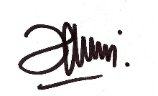

Anggriyani

NIM. 1826008

**TABLE OF CONTENTS**

COVER i

THESIS RATIFICATION i

ABSTRACT ii

STATEMENT OF AUTHORSHIP iv

ACKNOWLEDGEMENT v

TABLE OF CONTENTS vii

LIST OF TABLES viii

LIST OF FIGURES ix

LIST OF APPENDICES x

CHAPTER I 1

INTRODUCTION 1

A. Background of the Study 1

B. Research Question 3

C. Objective of the Study 3

D. Limitation of the Study 4

E. Significance of the Study 4

F. Definition of Key Terms 5

CHAPTER II 6

LITERATURE REVIEW 6

A. Concept of Free Writing 6

B. Writing Ability 9

C. Concept of Narrative Text 14

D. Relevant Research 17

E. Action Hypothesis 21

CHAPTER III 22

RESEARCH METHODOLOGY 22

A. Research Design 22

B. Research Setting 22

C. Research Instrument 23

D. Source of Data 23

E. Research Participants 24

F. Technique of Collecting Data 24

G. Research Procedure 26

H. Technique of Data Analysis 28

CHAPTER IV 31

FINDINGS AND DISCUSSION 31

A. Findings 31

B. Discussion 54

CHAPTER V 59

CONCLUSION AND SUGGESTION 59

A. Conclusion 59

B. Suggestion 59

REFERENCES 61

APPENDICES

**LIST OF TABLES**

Table 2.1 Relevant Research and Originality ……………………………..............17

Table 3.1 The Schedules of Research ……………………………….……....…….22

Table 4.1 The Results of Students’ Activities in Cycle 1 .........................................32

Table 4.2 The Results of Students’ Activities in Cycle 2 .........................................32

Table 4.3 Students’ Pre-test Scores ..........................................................................36

Table 4.4 The Result of Pre-Test ..............................................................................37

Table 4.5 Students’ Post-Test 1 Score ......................................................................42

Table 4.6 The Result Of Post-Test Cycle 1 ..............................................................43

Table 4.7 Students’ Post-Test 2 Scores .....................................................................49

Table 4.8 The Result of Post-Test Cycle 2 ...............................................................51

Table 4.9 Recapitulation of Students’ Score ............................................................56

**LIST OF FIGURES**

Figure 3.1 Reasearch Procedure ……………………………...………………….26

Figure 4.1 Students’ Learning Outcomes ………………………………………..57

**LIST OF APPENDICES**

1. Appendix 1: School Profile
2. Appendix 2: The Letters
3. Permission Letter
4. Letter of Conducting the Research
5. Appendix 3: Lesson Plan
6. Appendix 4: Test and Answer Key
7. Pre-test
8. Post-test Cycle 1
9. Post-test Cycle 2
10. Answer Key
11. Appendix 5: Results of Pre-Test, Treatment, and Post-Test
12. Pre-Test Results
13. Treatment Results in Cycle 1
14. Post-Test Results in Cycle 1
15. Treatment Results in Cycle 2
16. Post-Test Results in Cycle 2
17. Appendix 6: Assessment
18. Writing Assessment
19. Students Score of Pre-Test, Post-Test Cycle 1 and 2
20. Appendix 7: Observation Sheet in Cycle 1 and Cycle 2
21. Appendix 8: List of Student Attendance
22. Appendix 9: Interviews Data
23. Students’ Interview Guideline
24. Transcript Interview
25. Appendix 10: Documentation
26. Appendix 11: Researcher Biography

**CHAPTER I**

**INTRODUCTION**

1. **Research Background**

Writing is one of many communication forms to convey though or to express form of information through written pattern. Whenever writing is conducted, mostly people operate couple graphic symbols: such, letters or combinations of letters. In other words, writing has become the act of forming these symbols: making marks on a flat surface of some kind. However, writing is definitely much more than the production of graphic symbols. The symbols have to be arranged to form words, and the words have to be arranged to form sentences.[1] According to Chappell in Klimova, the importance of writing is can help a person with many things such as expressing personality, encourage communication, improve thinking skills, create persuasive logical arguments, give and receive feedback, prepare for education and employment.[2] In the Al-Quran, it also explains this matter in QS. Al-Alaq verses 4-5:

الَّذِيْ عَلَّمَ بِالْقَلَمِۙ ٤ عَلَّمَ الْاِنْسَانَ مَا لَمْ يَعْلَمْۗ ٥ ( العلق/96: 4-5).

Translation: “Who taught by pen, taught man that which he knew not”. (QS.

Al-'Alaq/96:4-5).[3].

In this verse, it is explained that a *Qalam* means everything that functions to write down the results of knowledge from reading.

The process of teaching writing skill has been introduced by many researchers of teaching methods or techniques in order to encourage students’ ability and enhance their learning process in Indonesia, in contrary, the English writing skill of students is still a major problem. The writing skills shared various complexity and most of the time for some teachers find it difficult to deliver at its best understanding of recipients, this due to requiring mastery not only of grammatical and theoretical devices but also conceptual and judgmental aspects.[4]

According to Pablo and Lasaten, the writing difficulties faced by language learners are identified and classified based on different ideas, namely content, ideas, organization, vocabulary, word choice, language use, formality, purpose, and reference. To acquire good writing skills, it is crucial to find the right approach or technique to minimize deficiencies and, importantly, to address the writing anxiety of language learners.[5] Harmer also found that starting is the hardest part of writing because students are reluctant to start again.[6]

Based on the preliminary observation, the researcher got information from the English teacher. She said that in learning English, most of the Tenth grade students at Madrasah Aliyah Swasta Alkhairaat Manado have difficulty in writing. Some students are not interested in learning to write because they have difficulty developing ideas for writing, while other students do not have enough vocabulary to develop their ideas when writing, some students still confused about the structure of the text itself, and there are students unable to make their writing grammatically correct. The English teacher said that during the writing test, at Tenth grade students of Madrasah Aliyah Swasta Alkhairaat Manado in the Academic Year 2024/2025, many students did not achived the minimum completeness criteria (KKM). The minimum completeness criteria at this school is 70. In classroom observations, the English teacher at this school uses the problem based learning method. This method is a learning activity that focuses on problem solving, where students must be active in critical thinking and always skilled when faced with solving a problem. In writing, most of the Tenth grade students still find it difficult to understand or to develop their writing ability, because a lack of interest and confidence in learning, which makes students struggle to solve the problems they face, it make them less active in learning activities.

The problem in writing according to Tri Oktavia Khaerani can resolved by using free writing technique. This technique encourages students to generate ideas in writing. During the implementation of the free writing technique, used several media that support this technique such as pictures, games, drawing activities, etc. The media made the students respond positively to the learning process. They no longer show any doubt in engaging in writing tasks. This also increases t heir motivation to write during the writing process.[7] Free Writing is a great technique for students to write freely without thinking about grammar, spelling, or topics within a short time during in class, usually around twenty minutes. This technique can even expand their vocabulary if done regularly at least three times a week before engaging in formal writing. If the students reach a point where they cannot think of anything to write, they can write that they cannot think of anything, until they find another topic to write about.[8]

To create an effective learning activity in the classroom, the researcher would implement the free writing technique in improving writing ability, the researcher was interested in researching by the title “The Use of Free Writing Technique in Improving Students’ Writing Ability at Tenth Grade Students of Madrasah Aliyah Swasta Alkhairaat Manado”.

1. **Research Question**

Based on the background above, the research questions is:

How does free writing technique improve students’ writing ability in narrative text at Tenth grade students of Madrasah Aliyah Swasta Alkhairaat Manado?

1. **Research Objective**

The objective of this study is to improve students’ writing ability in narrative text at tenth grade students of Madrasah Aliyah Swasta Alkhairaat Manado by using free writing technique.

1. **Research Limitation**

The researcher focused on free writing technique to improve students’ writing ability in narrative text with series of picture. The researcher chose narrative text because it is part of the tenth grade second semester material for the academic year 2024-2025 at Madrasah Aliyah Swasta Alkhairaat Manado.

1. **Research Significance**

This study will be beneficial to be used theoretically and practically, as follow:

1. Theoretically

This result of the study gives information about the use of free writing technique that can help students to write better easily. It can help the teacher in solving students' problems in writing.

1. Practically

The result of this study can be used to contribute practically, such as:

1. The Students

This research of this study is crucial for students to analyse their difficulties in writing and how free writing technique will significantly improve their writing ability. The students will be able to write easily and better.

1. The Teachers

This research can be sources of information or references for English teacher at school in order to improve their technique to academic writing.

1. Other Researcher

This research can serve as a useful reference for the future researchers who wish to explore the application of the free writing technique in improving students’ writing ability, as well as to support their own literature review.

1. **Definition of Key Terms**

To avoid mistakes and miss understanding terms and content of the topic on this study, it is necessary to define the key terms used in this study:

1. Free Writing

According to Schusther, free writing is a pre-writing process in which people write regularly during time not used for spelling, grammar, or content. This statement does not mean that students do not pay attention to elements of writing such as good organization, grammar, sentences, and words.[9]

1. Writing Ability

Writing ability is the process and action of gathering ideas and working with them until they are presented in a way that is polished and understandable to the reader. In other words, it's the process of arranging words, sentences, and paragraphs into meaningful ways so that readers understand what the author means.[10]

1. Narrative Text

Narrative text is a story that tells something interesting with the aim of entertain the reader. Narrative text tells a series of events in sequence that are so interconnected with each other. This text is imaginative or fictional in nature.[11]

**CHAPTER II**

**LITERATURE REVIEW**

1. **Concept of Free Writing**
2. Definition of Free Writing

According to Peter Elbow, the spontaneity of free writing relieves the mental burden of trying to “keep thinking about words while also worrying about whether they are words.” Free writing also allows students to write with more passion, focus, and energy for short, thought-provoking essays that help students explore and develop more ideas. When the stress of writing for the perfect product is removed, students will find that the writing process becomes fun, liberating, and motivating.[12]

According to Schusther, stated that free writing is a pre-writing process in which people write regularly during time not used for spelling, grammar, or content. This statement does not mean that students do not pay attention to elements of writing such as good organization, grammar, sentences, and words. The purpose of this process is for students to have the freedom to write whatever is on their mind, to easily get the ideas they express in their essays, and for them to then be accepted as good writing.[13]

Free writing means that once students know the meaning, they write sentences and expressions that come to their mind, using the missing sentences and expressions. See if students can write this in ten minutes or more. Students don't have to worry about correct spelling or punctuation, correcting mistakes they make, using equipment or the right words. Instead, come up with ideas by writing down everything that comes to your mind. If students have difficulty writing, repeat until students find another word. Students need to focus only on the short term given by the researchers. Therefore, they do not have time to correct their writing when they make mistakes.[14]

Based on the statement above, the researcher concludes free writing is a first way to get and then to develop ideas. When you free write and then you will be able to write freely without stopping on a topic for a specific amount of time. You just write down sentences as you think of them without worrying about whether your sentences are correct or not you also don’t have to punctuate sentences or capitalize words. You can even write incomplete sentences or phrases. The main goal in free writing is to keep your pencil moving across the paper. Free writing also stream of consciousness writing is a writing technique in which a person writes continuously for a set period of time without regard to spelling, grammar, or topic. It produces raw, often unusable material, but helps writers overcome blocks of apathy and self-criticism. It is used mainly by process writers and writing teachers. Some writers use the technique to collect initial thoughts and ideas on a topic, open as a preliminary to formal writing. It is not automatic writing.

1. The Purpose of Free Writing

The purpose of free writing is to gain enough ideas so that one can put them into writing. The goal of free writing is to create as much text as possible without worrying about grammar and accuracy, speeding up your writing and developing ideas you can use in future writing.[15]

1. The Steps of Free Writing

In this study, the researchers asked the students to write a sentence that they want to write, and when doing free writing, they ask the students to pay attention only to the content or process of writing. There are also great student activities for writing classes. Tri Oktavia Khaerani explains:[16]

You can follow these steps to write for free writing:

1. Select the idea you like from your list of changes.
2. Write this idea on a clean piece of paper.
3. Spend ten minutes without thinking on this topic. This means you need to write something.
4. Write down everything that comes to your mind.
5. Don't judge your feelings.
6. Don't worry about spelling and grammar.
7. If you have nothing to say, go ahead and write whatever comes to your mind.

This process is called free writing. It's designed to help you collect free ideas you don't know about. One of the great things about free writing is that you don't have to worry about spelling, and punctuation as you write.

1. The Advantages and Disadvantages of Free Writing Technique

As stated by Clarkson, he explains several advantages of free writing techniques, as follows:[17]

1. It makes you feel comfortable about writing.
2. It helps you overcome your inner critic who tells you you can't write.
3. It helps to trust from within.
4. This can help you find topics to write about.
5. It can help you improve your writing skills.
6. That's interesting.

Free writing also has its disadvantages, students should be prepared for important steps such as preparation and how students will prepare their writing topics. Then students should know all the steps to classify the writing according to their own ideas. Therefore, teachers should help students get the correct information to complete the work because the student’s goal is to create the work that the teacher supports.

1. **Writing Ability**
2. Definition of Writing

According to Oxford, writing is activity of writing, written words of an author and handwriting.[18] “Writing is a medium of human communication that represents language and emotion with signs and symbols. In most language, writing is a complement to speech or spoken language. Writing is not a language, but a tool used to make languages be read. Within a language system, writing relies on many of the same structure as a speech, such as vocabulary, grammar, and semantics, with the added dependency of a system of signs or symbols.”

Writing definition above is similar with writing definition by Mario Pei in his book with entitle “The History of Language”. He states that writing is a symbol of the spoken language, less arbitrary than the language itself, since in most system of writing there is an attempt to make characters correspond to sounds.[19] Bram defines that writing is producing or reproducing written message. It is an active process to organize ad formulate the ideas on the paper. Therefore, before we write we need to determine what the writer shall have something meaningful to convey.[20] Rivers says that writing is an exciting challenging skill where the students are given permit to indulge in fantasy, humor, fiction, or fact in language.[21]

Based on the opinion above, the researcher concludes that writing is a kind of activity where the writer expresses all the ideas in his/her mind, thinking, and feelings in the paper from words to sentences, sentences to paragraph and from paragraph to essay. In relation to the organization of the ideas on the paper, a researcher should have an ability to balance the purpose, audience and topics as well as speaking activity. Langan says that writing is a skill that anyone can learn with practice. When we write, we give full shape to our thought and feelings then put into written form.[22]

1. Components of Writings

There are five main components of writing. They are content, organization, grammar, vocabulary and mechanics.[23]

1. Content

According to Oxford learners pocket Dictionary content is writing and speaking subject in a book or a program. The content of writing should be clear enough for readers so that the readers can understand the message and gain information in it, besides that, its content should be also well unified and complete.

1. Organization

Heaton that judgment skills or organization is the ability of writer to write in an appropriate manner for a particular purpose with a particular audience in mind, also to select, organize and order relevant information. Organization of writing concern with the ways, the writer arranges and organizes the ideas in the writing. It could be chronological order, order of importance, general to particle order, particular to general order.

1. Grammar

To have a good grammar in writing, writer should a pay attention to the use of grammatical rules concerning tenses, preposition, conjunction, clause (adjective and verbal clause), article, etc. The lack of knowledge of grammar will make the readers misunderstanding about the content of writing.

1. Vocabulary

According to oxford learners pocket dictionary vocabulary is total number of words in a language. Ones can write anything if she or he has vocabulary to express. He or she should express the ideas in form of words or vocabulary. The lack of vocabulary makes someone fails to compose what he or she are going to say because she or he fells difficult to choose word appropriate. Vocabulary will help the writer to compose the writing and also make readers easy to understand.

1. Mechanics

According to Heaton writing mechanics skills are the ability of writer to use correctly those conventions peculiar to the written language.[24] The use of mechanism is due to capitalization, punctuation, spelling appropriately. This aspect is very important because it can make readers understand what the writer means to express definitely. Based on the opinion above the readers can easy to group the conveying ideas or massage to writing material if they use of favorable mechanism in writing. All of the components were used for analysis the data quantitatively. They were content, vocabulary, organization, grammar and mechanics. Although grammar was not task, but the researcher used it for analysis data because the researcher thought that grammar was so important to get a good writing.

1. The Process of Writing

When students are writing, we will want to involve them in the process of writing. In the ‘real word’, this typically involves planning what we are going to write, drafting it, reviewing and editing what we have written and then producing a final (and satisfactory) version.[25]

1. Planning

Planning is the process of making plans for what they are going to write. Before starting to write or type, they try and decided what it is they are going to say. When planning, writers have to think about three main issues. In the first place they have to consider the purpose of their writing since this will influence (amongst other things) not only the type of text they wish to produce, but also the language they use, and the information they choose to include. Secondly, experienced writers think of the audience they are writing for, since this will influence not only the shape of the writing (how it is laid out, how the paragraphs are structured, etc.), but also the choice of language whether, for example, it is formal or informal in tone. Thirdly, writers have to consider the content structure of the piece that is how best to sequence the facts, ideas, or arguments which they have decided to include.

1. Drafting

It refers to the first version of a piece of writing as a draft. This first ‘go’ at a text is often done on the assumption that it will be amended later. As the writing process proceeds into editing, a number of drafts may be produced on the way to the final version.

1. Editing (reflecting and revising)

Once writers have produced a draft they then, usually read through what they have written to see where it works and where it doesn’t. Perhaps the order of the information is not clear. Perhaps the way something is written is ambiguous of confusing. They may then move paragraphs around or write a new introduction. They may use a different form of words for a particular sentence. More skilled writers tend to look at issues of general meaning and overall structure before concentrating on detailed features such as individual words and grammatical accuracy. The latter two are important and are often dealt with later in the process. Reflecting and revising are often helped by other readers who comment and make suggestions. Another reader’s reaction to a piece of writing will help the author to make appropriate revisions.

1. Final Version

Once writers have edited their draft, making the changes they consider to be necessary, they produce their final version. This may look considerably different from both the original plan and the first draft, because things have changed in the editing process. Even, when they think is their final draft, they may find themselves changing their mind and then re-planning, re-drafting, or re-editing.

1. Characteristic of Writing

Nunan points out the successful writing as follows:[26]

1. Mastering the mechanics of writing
2. Mastering and pay attention about spelling and punctuations
3. Using the grammatical system to understand the meaning
4. Organizing content at the level of paragraph and the complete text to reflect the given new information and topic comment structures
5. Polishing and revising one’s initial efforts.
6. Selecting an appropriate style for one’s audience.

Based on the opinion above, the researcher concludes that the writers can get successful writing if the writers pay attention with five components of writing; they are content, organization, grammar, vocabulary, and mechanics. Also give revising one’s initial efforts. Mustafir states that most effective writer would probably agree that good writing has several important characteristics, namely:[27]

1. Good writing like a good film or song or friend, is interesting, enjoying, it keeps your interest by what it says and how is says it.
2. Good writing is not difficult to follow because it follows a plan.
3. Good writing presents ideas that are fresh and original, not hand me down, tired ideas borrowed from someone else. As a result, it sounds like its author rather than sounding generic.
4. Good writing uses language that is right for the formal job when required and informal when appropriate.
5. Good writing is mistakes in grammar, spelling, and punctuation are nothing matters because those errors get in the way of the writers’ ideas and distract the readers.

Based on the opinion above, it can be concluded that the characteristics of good writing are good writing make readers understand what writers say, readers feel happy if they read, and it focuses on meaning rather than form.

1. **Concept of Narrative Text**
   1. Definition of Narrative Text

Narrative text is a story that tells something interesting with the aim of entertain the reader. Narrative text is a story that discusses past activities or events in sequence to create a problem and provide a lesson to the reader.[28] Narrative text can be fiction or non-fiction that contain a series of events where the story is told and the context is provided as a feature of story development.[29] From the definition above, narrative text is a text that contains a story arranged chronologically. The Readers often feel satisfied with the content of the story after reading the text, and they find valuable lessons for their lives. So, narrative text always have moral values in their content.

The function of narrative text is as a medium to reconstruct the past events or even the experiences. The story in the narrative text is usually telling the past issue and using the past tense.[30] Narrative text can be a fairy story, fable, science fiction story, romantic story, humorous story, travelogue, ghost story, crime story, thriller, folk-tale, and many more. However, it is generally distinguished into two forms namely fictional and non-fictional.

* 1. Generic Structure of Narrative Text

The generic structure of narrative text are contain of orientation, complication, resolution, and re-orientation.[31]

1. Orientation

Orientation is the first step of a narrative text. This step introduces the characters in the story as well as the setting of the story, which includes the location, time, atmosphere, and social conditions. (setting).

1. Complication

This step contains the problems that occur within a story. Such as the problems starting to emerge, the peak of the problems, the tension of the problems beginning to decrease, and starting to find a resolution point.

1. Resolution

This step contains the resolution or ending of a narrative text. A story can be concluded with a happy ending or sad ending.

1. Re-orientation

The last step of the narrative text usually contains a conclusion, a moral value, or a change in the character's personality at the end of the story. This re-orientation is optional because it does not always have to be present in a narrative text.

* 1. Language Features of Narrative Text

According to Pardiyono, the language features of narrative text as follow:[32]

1. The use of predicate with form verb past continuous tense, past tense, and past perfect tense.
2. The use form verbs of doing in predicate that indicate the action of the doer in the story.
3. The use of adjective word points out the character of participant or personal attitude of participant in the story.
4. The repetition of the same subjective pronoun in the text is common.
5. The use of conjunction is common use in story.
   1. Types of Narrative Text

There many different types of narrative texts:[33]

1. Humor, a story meant to make the reader laugh or feel entertained. It often includes funny events, wordplay, or silly character.
2. Romance, focuses on love and emotional relationships between characters. Usually includes emotional conflict and romantic resolutions.
3. Crime, involves criminal acts and investigations, usually with a detective or protagonist solving the case.
4. Real Life Fiction, fictional stories that are based on real-life situations. The characters and events are realistic and relatable.
5. Theoritical fiction, possible meant as philosophical or historical fiction. If meant as philosophical, it explores deep ideas or concepts, like ethics, existence, or social questions. If meant as historical fiction, it tells fictional stories set in real historical.
6. Mystery, a story built around a puzzle or unknown event, where the main character tries to find answers.
7. Fantasy, set in imaginary worlds with magic, mythical creatures, and supernatural powers. Often not bound by real-world logic.
8. Science Fiction, based on science and futuristic technology, such as space travel, robots, or artifical intelligence.
9. Diary Novels, stories told in the form of a character’s personal diary or jurnal, giving an emotional and intimate point of view.
10. Adventure, focuses on action, exploration, and challenging journeys. The characters often face danger or seek something important.
11. **Relevant Research**

**Tabel 2.1**

**Relevant Research and Originality**

|  |  |  |  |  |
| --- | --- | --- | --- | --- |
| **No.** | **Research Identity** | **Similarity** | **Differences** | **Research Originality** |
|  | **Tri Oktavia Khaerani.** The Use of Free Writing Technique in Improving Writing Ability of Class VII B Students at SMP Muhammadiyah 2 Mlati in the Academic Year of 2014/2015**[34]** | This study analysed  the use of free  writing technique to improve writing ability, this study conducted the Classroom Action Research, and technique analysis  used qualitative and quantitative. | The location of the study, subject of the study, and the test using recount text. | This study is a Classroom Action Research (CAR) at Tenth grade students of MAS Alkhairaat Manado which focused on the use of free writing technique in improving students’ writing ability in Narrative text |
|  | **Juliati.** The Use of Free Writing Strategy in Teaching Writing at VIII Grade Students at SMPN 1 Pajo in  the Academic Year of 2018/2019[35] | This study use of tests as the same instrument by researcher to determine whether the free writing technique can improve students’ writing ability. | The location of the study, subject of the study, and this study used experimental research. The test used descriptive text. |  |
|  | **Ayu Wulandari.** The Effect of Using Free Writing Technique on Students Ability in Writing Recount Text at Madrasah Aliyah Al-Ihsan Boarding School Riau**[36]** | This study analysed the using free writing technique to improve writing ability. This study was also conducted the quantitative method. | The location of the study, subject of the study, used experimental research, and the test used recount text. |  |
|  | **Abdur Rahim** **Basriansyah.** The Use of Free Writing Technique in Improving Writing Ability of Class XI Student at MAN 4 Banjar in the Academic Year of 2017/2018[37] | This study analysed  the using freewriting technique to  improve writing ability. This study  was also conducted  the quantitative method. | The location of the study, subject of the study, used experimental research, and the test used recount text. |  |
|  | **Nurrahmayani, A.**  The Building Up Writing Ability Through Free Writing Technique in The 1st Grade Students at MA AL Mubarok DDI Tobarakka Kab. Wajo [38] | This study analysed the using free writing technique to improve writing ability, and use of tests as the same instrument by researcher to determine whether the free writing technique can improve students’ writing ability. | The location of the study, subject of the study, this study used pre-experimental design, and the test used descriptive text. |  |

From the table above, showed previous research related to this research. The first is the research that has been done by Tri Oktavia Khaerani with the title “*The Use of Free writing Technique in Improving Writing Ability of Class VII B Students at SMP Muhammadiyah 2 Mlati in the Academic Year of 2014/2015”*. The differences in this study are the location of the study, subject of the study, and the test using recount text. The similarity of this study are this study analysed the use of free writing technique to improve writing ability, this study conducted the Classroom Action Research design, and technique analysis used qualitative and quantitative.

The second study is the research that has been done by Juliati with the title “*The Use of Free Writing Strategy in Teaching Writing at VIII Grade Students at SMPN 1 Pajo in the Academic Year of 2018/2019*”. The differences in this study are the location of the study, subject of the study, this study used experimental research, and the test used descriptive text. The similarity of this study are in the use of tests as the same instrument by researcher to determine whether the free writing technique can improve students’ writing ability.

The third study is the research that has been done by Ayu Wulandari with the title “*The Effect of Using Free Writing Technique on Students Ability in Writing Recount Text at Madrasah Aliyah Al-Ihsan Boarding School Riau*”. The differences in this study are the location of the study, subject of the study, used experimental research, and the test used recount text. The similarity of this study are this study analysed the using free writing technique to improve writing ability, and this study was also conducted the quantitative method.

The fourth study is the research that has been done by Abdur Rahim Basriansyah with the title “*The Use of Free Writing Technique in Improving Writing Ability of Class XI Student at MAN 4 Banjar in the Academic Year of 2017/2018*”. The differences in this study are the location of the study, subject of the study, used experimental research, and the test used recount text. The similarity of this study are this study analysed the using free writing technique to improve writing ability, and this study was also conducted the quantitative method.

The fifth study is the research that has been done by A. Nurrahmayani with title “*The Building Up Writing Ability Through Free Writing Technique in The 1st Grade Students at MA AL Mubarok DDI Tobarakka Kab. Wajo*”. The differences in this study are the location of the study, subject of the study, this study used pre-experimental, and the test used descriptive text. The similarity of this study are this study analysed the using free writing technique to improve writing ability, and use of tests as the same instrument by researcher to determine whether the free writing technique can improve students’ writing ability.

Based on the five previous studies, it can be concluded that the research has the same objective, which is to improve students' English writing ability through the free writing technique. However, there are notable differences between those studies and the present research, particularly in terms of the research design, and the type of texts used. While the previous studies employed recount and descriptive texts, this study focuses on narrative texts. These distinctions make this research unique compared to the five earlier studies. In this case, the researcher expected that by applying free writing technique, it can help students improve their narrative text writing ability.

1. **Action Hypothesis**

The implementation of free writing technique is expected to improve the writing ability of tenth grade students at Madrasah Aliyah Swasta Alkhairaat Manado, with a target achievement of 60% of the student achieve minimum completeness criteria, 70. It is expected that through this technique, students will become more confident, expressive, and motivated in writing, resulting in better performance in aspects such as content, structure, vocabulary, language use, and mechanics. Thus, their writing ability can improve and their scores can achieve the minimum completeness criteria.

**CHAPTER III**

**RESEARCH METHODOLOGY**

1. **Research Design**

The researcher used Classroom Action Research (CAR) as the method. It was conducted in a classroom to determine the consequences of actions applied to subjects in that class.

CAR was defined as action research, the goal is to improve the quality of a group of things being work on or solve a problem, monitor the success or outcome of the action, and then provide follow-up actions to improve the action, or the importance of adapting to conditions and situations, the importance of achieving better results.[39]

The purpose of this classroom action research was to improve the students writing ability through the free writing technique. In this research, the researcher used two cycles.

1. **Research Setting**

This research was carried out at Madrasah Aliyah Swasta Alkhairaat Manado. Located at Jl. Pesantren, Mapanget Barat Sub-district, Manado City, North Sulawesi Province. Focusing to the tenth grade second semester on academic year 2024/2025. This research was conducted on 30 April 2025 to 20 May 2025.

**Table 3.1**

**The Schedules of Research**

|  |  |  |
| --- | --- | --- |
| **Date** | **Time** | **Stages** |
| Wednesday, 30 April 2025 | 08.00-09.00 am | Pre-Test |
| Saturday, 03 May 2025 | 10.00-11.30 am | First Meeting (Cycle 1) |
| Monday, 05 May 2025 | 08.00-09.30 am | Second Meeting (Cycle 1) |
| Wednesday, 07 May 2025 | 08.00-08.30 am | Third Meeting (Cycle 1) |
| Saturday, 10 May 2025 | 10.00-11.00 am | Post-Test Cycle 1 |
| Wednesday, 14 May 2025 | 08.00-09.30 am | First Meeting (Cycle 2) |
| Saturday, 17 May 2025 | 10.00-11.30 am | Second Meeting (Cycle 2) |
| Monday, 19 May 2025 | 08.00-09.30 am | Third Meeting (Cycle 2) |
| Tuesday, 20 May 2025 | 08.00-09.00 am | Post-Test Cycle 2 |

1. **Research Instrument**

Research instruments that were used by researcher in this research included observation, tests, interview, and documentation. The researcher used observation as an instrument to observe situations that occured during the teaching and learning process. The tests were instruments used by researcher to determine the improvement of students’ abilities in writing. The interviews were used by researcher to learn about the problems that students faced when learning writing. The researcher collected documentation such as school profiles, lesson plans, students’ test sheet, students learning outcomes reports, photos during the research, observations checklist, and transcript interview.

1. **Source of Data**

1. Primary Data

Primary data were data sources that could directly provide valuable information.[40] The primary data in this research were the results of students’ writing ability tests. This research used qualitative and quantitative methods. Qualitative data were collected from observations, interviews, and documentations. While quantitative data were obtained through the final grades of students learning outcomes.

1. Secondary Data

Secondary data were data sources that provide data to research indirectly through other researchers or documents rather than directly. Such as several journals and articles relate to the research were used as secondary data.

1. **Research Participants**

The participants in this research were the students from the tenth grade of Madrasah Aliyah Swasta Alkhairaat Manado, second semester in the Academic year 2024/2025. The researcher chose them as participants to found out the problems they have in learning writing. Students from the tenth grade were select as participants with a total of nineteen (19) students. They were consisted of thirteen (13) male students and six (6) female students.

1. **Technique of Collecting Data**

Data plays a significant role in research because the research conclusion was derived from the data. The researher was gathered data to support this research. The researcher’s data collection techniques and methods used were qualitative and quantitative data included observation, tests, interview, and documentation.

The techniques of collecting data employed in this research were:

1. Qualitative Data
2. Observation

Observation is a method of gathering information by observing research objects or events. Observation can be done through sight, smell, hearing, touch and taste and can be understood as direct observation. In this study, a survey created by the researcher with teacher guidance will be used.[41] The researcher was observed the use of free writing techniques in the classroom throughout the treatment.

1. Interview

Interviews are use as a data collection technique if the researcher wants to conduct a preliminary study for find problems that need to be researched, and also if the researcher wants to know things from the respondent more in-depth and the number of respondents little/small.[42] The researcher used interview to found out general overview of the language learning process English. In this research, the researcher was conducted interviews with the students at tenth grade with six types of questions.

1. Documentation

Documentation is the process of gathering facts or information about a particular topic. Data is saved (book, photo, video, audio recording, etc).[43] In this research, the researcher used school profiles, lesson plans, students learning outcomes reports, students’ test sheet, photos during the research process, observation sheet, and transcript interview.

1. Quantitative Data

In this research, the researcher gave a test to the students in order to evaluate their writing ability. Test is a set of statements or questions use to assess an individual or group skill, ability, intelligence, and knowledge. Test is a process of measuring a person’s ability in a specific domain.[44] For this research, the test used series of pictures as media to observed by students, and present in the form of narrative text based on the observations made. This test was conducted individually and groups.

1. Pre-test

Pre-test was a step taken by the researcher to measure each student's initial ability, and this was done before the researcher applies the free writing technique. This activity was given in the first meeting before the researcher conducts the study. The researcher was provided an exercise about narrative story with the titled “The Story of Lake Toba”, and the students was rewrite it according to their understanding in the narrative text format.

1. Post-test

Post-test was conducted at the end of each cycle. The purpose of this test was to determined whether the students' writing ability have improved or not. The result of the treatment was the post-test. If the average post-test score was higher than the pre-test score, then the result indicates an improvement in the students' writing ability in narrative text. In cycle 1, the researcher used series of picture about a folktale, and the students was arranged the folktale into a narrative text. Then in cycle 2, the researcher still used the same media, which was series of pictures. However, using a different story, namely fables.

1. **Research Procedure**

The model develop by Kemmis and McTaggart in Burns was used by researcher. Action research is conducted in a dynamic and complementary process that consist of four steps.[45] The four steps of classroom action research were as follows: planning, action, observe, and reflect.

**Figure 3.1**

**Research Procedure**

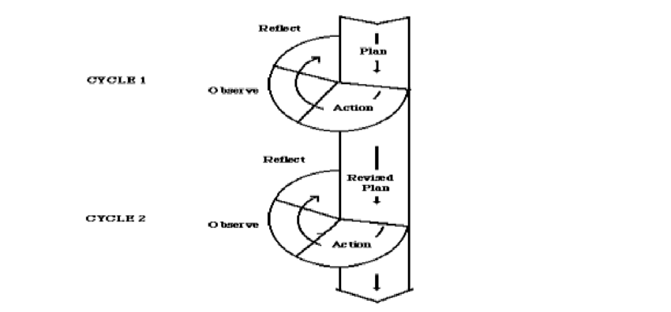

This classroom action research was divided into two cycles. There were cycle 1 and cycle 2. The minimum completeness criteria in Madrasah Aliyah Swasta Alkhairaat Manado was 70. The researcher made the target achievement in cycle 1 and cycle 2 were 60%.

The following activities were carried out in each cycle:

1. Cycle 1
2. Planning

Planning is the first process of research to take action after confirming the research problem. Researcher need to prepare before conducting action research. At this step, the researcher was prepared the materials to be used in the research process or prepares the materials needed in the learning process such as lesson plans, materials on narrative text, teaching media, observation sheets, and attendance lists. In this cycle the meeting time was three times.

1. Action

Action was the execution of planning. The researcher acted as the teacher. The students and the English teacher acted as observers who carried out activities based on the planning that has been done in class. In this case, the English teacher helped in the observation activities. The researcher was trying to measure students' ability to comprehend written texts. The researcher explained about the free writing technique and narrative text. The researcher used series of pictures as a media to taught narrative text material. The researcher assiged tasks to students individually and groups to engaged in free writing activities using themes according to showing the series of picture, then asked the students to wrote down any words that come to their minds. Then, evaluated their weaknesses.

1. Observation

The researcher observed all events or activities during the treatment. The researcher observed the classroom situation during the learning process, paying attention, respond during learning, enthusiasm doing the exercise, and work in pairs. In addition to using observation checklist. This observation was very important for analyzing everything that happens in the class during the free writing activity.

1. Reflection

Reflection means analyzing the results based on the data that has been collected to determine the next actions in the following cycle. At this point, researcher and English teacher doing evaluated and identify the effects of the actions to understand what has happened. The researcher then decided to conduct further action research cycles to fix the situation and the weaknesses. The researcher refers to the results of observations conducted in the classroom, and the results obtained by students from the post-test scores. The researcher compared the pre-test and post-test scores of cycles 1. Therefore, if the results obtained by the students do not meet the specified criteria, the researcher conducted next treatment.

1. Cycle 2

Based on reflection in the cycle, the researcher decided to continue with cycle two in order to helped students understand and improve their writing ability. The steps were like cycle 1.

1. Planning

The researcher revised the lesson plans and continue with carrying out the same teaching and learning process as the planning in cycle 1. In this cycle the meeting time was three times.

1. Action

The researcher using the new lesson plans, and give the students the same test but with a different story to see whether they could improve their writing ability by using the free writing technique. The researcher observed students activities during the teaching and learning process.

1. Observation

The researcher observed the classroom situation during the learning process, paying attention, asking questions, responses, and the attitudes of students when they are given explanations, doing assignments, and identifying their difficulties. In addition to using observation checklist like in cycle 1.

1. Reflection

Reflection was done after teaching and learning process. In this step, the researcher examined the test and compared the results of pre-test and post-test scores. This step was carried out to determine whether there was a improvement in students’ writing ability by using the free writing technique in narrative text.

1. **Technique of Data Analysis**

In this research, the researcher was analyzed data from both qualitative and quantitative. For qualitative data analysis, the researcher accumulated and analyzed the data through observation, interview, and documentation. Creswell explained that qualitative data analysis as having some stages such as organizing, familiarizing, coding, reducing, interpreting, and representing.[46]

For quantitative data analysis, the researcher was calculated the averange pre-test and post-test scores. The researcher was compared the pre-test and post-test scores to detemine the level of improvement. The results were compared with the minimum completeness criteria. The minimum completeness criteria for English in the tenth grade at Madrasah Aliyah Alkhairaat Manado is 70.

To analyzed the data, the researcher used the formula below to calculate the average score:[47]

Note :

X : Averange (mean) of the student score

∑X : The sum (total) score

∑N : Number of the students

In the next stage, the researcher was to analyze the class percentage that passes the minimum completeness criteria (KKM) using the English subject. The researcher then attempted to found the class percentages that pass the KKM as adapted from Madrasah Aliyah Swasta Alkhairaat Manado using Sudijono's formula:[48]

Note :

P : The class percentage

F : an entire student who pass KKM

N : Number of students

Then, the researcher analyzed the students’ writing ability scores from pre-test to post-test. This used to found out whether there was an improvement in cycle 1 and cycle 2 or not. The formula as follows:[49]

**P = × 100%**

P : Percentage of students’ improvement

y : Pre-test result

y1 : Post-test result cycle I

**P = $\frac{y2 - y}{y}$ × 100%**

P : Percentage of students’ improvement

y : Pre-test result

y2 : Post-test result cycle II

**REFERENCES**

A, Cynthia. *Bordman and Jia Frydenberg. Writing to Communicate*, (USA: Longman, 2008)

A. Rakhmi, *Let's Narrate a Text*. (Jakarta: PT Balai Pustaka Persero, 2012)

Anderson, K. & Anderson, M. *Text Types in English* 2. South Yarra: MacMillan, 2003)

Ary, Donald. et all., *Introduction to Research in Education* (United States: Wadsworth Cengange Learning, 2006)

B. F Klimova. (2012). *The Importance of Writing.* Paripex - Indian Journal Of Research, 2(1)

Bram Balley, *Write Well Improving Writing Skill* (Yogyakarta: Canisius, 1995)

Burns, Anne. *Doing Action Research in Language Teaching* (New York: Routledge, 2010)

Byrne, Donn. *Teaching Writing Skill* New Edition (England: Longman Group UK Limited, 1988)

Clarkson, R. *“Free writing a Great Technique to Practice English”*. 2009.

Daryanto, *Penelitian Tindakan Kelas dan Penelitian Tindakan Sekolah* (Yogyakarta: Gavamedia, 2018)

Douglas Brown, *Teaching by Principles* (New York: Pearson Education, 2002)

Faizah, Baharudin, et al., *Process of Writing: The Challenges in Writing Skill Among ESL Learners* In International Journal Of Academic Research In Business And Social Sciences Vol. 13, No. 10, 2023

Harmer, Jeremy. *How to Teach Writing* (England: Pearson Education Limited, 2004)

Heaton J.B, *Writing English Language Tests* (London: Longman, 1975)

J, Barwick, *Targeting Text: Narrative, Poetry, Drama, Upper Level,* (Singapore: Green Giant Press, 2006)

Juliati*. “The Use of Free Writing Strategy in Teaching Writing at VIII Grade Students at SMPN 1 Pajo in the Academic Year of 2018/2019”.* (Muhammadiyah University of Mataram, 2019)

Juliati*. “The Use of Free Writing Strategy in Teaching Writing at VIII Grade Students at SMPN 1 Pajo in the Academic Year of 2018/2019”.* (Muhammadiyah University of Mataram, 2019)

Lajnah Pentashihan. *Mushaf Al-quran*. 2019

Langan J. *English skill* (New York: McGraw-Hill Companies,2001)

Langan, J. *College Writing Skills with Readings. New York*: McGrawHill. 2008)

Linse, T. *Practical English Teaching: young Learner*. North America: Mc-Graw Hill ESL/ELT, 2005)

M Rivers Wilga, *Interactive Language Teaching* (New York: Cambridge University Press, 1987)

Mario Pei, *The Story of Language* (United States of America: J.B. Lippincott Company, 1949)

Meltzer David E, *“The Relationship between Mathematics Preparation and Conceptual Learning Gains in Physics: A Possible Hidden Variable in Diagnostic Pretest Score”* (Iowa: Department of Physics and Astronomy, Iowa State University, 2008)

Meltzer, David E. *“The Relationship between Mathematics Preparation and Conceptual Learning Gains in Physics: A Possible Hidden Variable in Diagnostic Pretest Score”* (Iowa: Department of Physics and Astronomy, Iowa State University, 2008)

Moleong, Lexi J. *Metode Penelitian Kualitatif,* (Bandung: PT. Remaja Rosdakarya, 2014)

Mu’alimin and Rahmat Arofah Hari Cahyadi, *Penelitian Tindakan Kelas Teori dan Praktik* (Sidoarjo: Gading Pustaka, 2014)

Mustafir Masfiah, *Developing the Writing Ability of the Second Year Students of SMP I Bissapu Bantaeng Through Reproduction* (Thesis FBS UNM 2002)

Neo Ernest. *Narrative for ‘O’ Level.* (Malaysia: Longman, 2005)

Nunan David, *Designing Tasks for the Communicative Classroom* (New York: Cambridge University Press 1989)

Nurrahmayani, A*.” The Building Up Writing Ability Through Free Writing Technique in The First Grade Students at MA AL Mubarok DDI Tobarakka Kab. Wajo”.* (Islamic State Institute Pare Pare, 2020)

Oxford University Press, *Oxford Learner’s Pocket Dictionary,* Third Edition (printed in China, 2003)

Pardiyono, *Teaching Genre-Based Writing*, (Yogyakarta: Andi Offiset, 2007)

Rahim, Abdul*. “The Use of Free Writing Technique in Improving Writing Ability of Class XI Student at MAN 4 Banjar in the Academic Year of 2017/2018”.* (Antasari State Islamic University Banjarmasin, 2018)

Richard Jack C, Rodgers and Theodore, *Approaches and Methods in Language Teaching* (New York: Cambridge University Press 1995)

Schusther, S*. Essay Writing Step by Step*. (Canada Kaplan Publishing, 2003)

Sinaga, Asima Rohana, et al., *“The effect of free writing technique on students’ writing ability”* Vol. 8 No.1 Juli 2022

Sudijono, Anas. *Pengantar Statistik Pendidikan* (Jakarta: PT. Grafindo Persada, 2008)

Sugiyono, *Metode Penelitian Pendekatan Kuantitatif, Kualitatif dan R&D* (Bandung: Alfabeta, 2010)

Suharismi Arikunto, *Prosedur Penelitian Suatu pendekatan Praktik.* (Jakarta: Rineka Cipta, 2006)

Tri Oktavia, Khaerani. *“The Use of Free Writing Technique in Improving Writing Ability of Class VII B Students at SMP Muhammadiyah 2 Mlati in the Academic Year of 2014/2015‟* (State University of Yogyakarta, 2015)

Wulandari, Ayu*.* *“The Effect of Using Free Writing Technique on Students Ability in Writing Recount Text at Madrasah Aliyah Al-Ihsan Boarding School Riau”*,(State Islamic University of Sultan Syarif Kasim Rau, 2020).

Y. Li, Linda. *“Exploring the Use of Focused Freewriting in Developing Academic Writing”*, Journal of University Teaching & Learning Practice, Vol.4 (2007)

1. Donn Byrne. *Teaching Writing Skill* New Edition (England: Longman Group UK Limited, 1988), p. 1
2. Klimova, B. F. (2012). *The Importance of Writing.* Paripex - Indian Journal of Research, 2(1), p. 9
3. Lajnah Pentashihan. *Mushaf Al-quran*. 2019.
4. Don Byrne. *Teaching Writing Skills, New Edition* (England: Longman Group UK Limited, 1988), p. 4.
5. Baharudin, Faizah, et al., *Process of Writing: The Challenges in Writing Skill Among ESL Learners* In International Journal Of Academic Research In Business And Social Sciences Vol. 13, No. 10, 2023. p. 35.
6. Jeremy Harmer, *How to Teach Writing* (England: Pearson Education Limited, 2004), p. 4.
7. Khaerani, Tri Oktavia. “The Use of Free Writing Technique in Improving Writing Ability of Class VII B Students at SMP Muhammadiyah 2 Mlati in the Academic Year of 2014/2015‟ (State University of Yogyakarta, 2015).
8. Asima Rohana Sinaga, et al., *“The effect of free writing technique on students’ writing ability”* Vol. 8 No.1 Juli 2022, p. 354.
9. Schusther, S*. Essay Writing Step by Step*. (Canada Kaplan Publishing, 2003). p. 13.
10. Linse, T. *Practical English Teaching: young Learner*. North America: Mc-Graw Hill ESL/ELT, 2005). p. 98.
11. Pardiyono, *Teaching Genre-Based Writing*, (Yogyakarta: Andi Offiset, 2007), p. 94.
12. Linda Y. Li, *“Exploring the Use of Focused Freewriting in Developing Academic Writing”*, Journal of University Teaching & Learning Practice, Vol.4 (2007), p. 42.
13. Schusther, S. *Essay Writing Step by Step*. (Canada: Kaplan Publishing, 2003). p. 13.
14. Langan, J. *College Writing Skills with Readings. New York*: McGrawHill. 2008). p. 18.
15. Cynthia A. *Bordman and Jia Frydenberg. Writing to Communicate*, (USA: Longman, 2008), p. 22.
16. Tri Oktavia Khaerani*. “The Use of Free Writing Technique in Improving Writing Ability of Class VII B Students at SMP Muhammadiyah 2 Mlati in the Academic Year of 2014/2015‟* (State University of Yogyakarta, 2015). p. 22.
17. Clarkson, R. *“Free writing a Great Technique to Practice English”*. 2009.
18. Oxford University Press, *Oxford Learner’s Pocket Dictionary,* Third Edition (printed in China, 2003), p. 502
19. Mario Pei, *The Story of Language* (United States of America: J.B. Lippincott Company, 1949), p. 86.
20. Balley Bram, *Write Well Improving Writing Skill* (Yogyakarta: Canisius, 1995), p. 3.
21. Wilga M Rivers, *Interactive Language Teaching* (New York: Cambridge University Press, 1987), p. 91.
22. John Langan, *English skill* (New York: McGraw-Hill Companies,2001), p. 2.
23. Jack C Richard, Rodgers and Theodore, *Approaches and Methods in Language Teaching* (New York: Cambridge University Press 1995), p. 15.
24. J.B. Heaton, *Writing English Language Tests* (London: Longman,1975), p. 135.
25. J.B Heaton, *Writing English Language Tests* (London: Longman 1975), p. 156
26. David Nunan, *Designing Tasks for the Communicative Classroom* (New York: Cambridge University Press 1989), p. 46
27. Masfiah Mustafir, *Developing the Writing Ability of the Second Year Students of SMP I Bissapu Bantaeng Through Reproduction* (Thesis FBS UNM 2002), p. 6.
28. Pardiyono, *Teaching Genre-Based Writing*, (Yogyakarta: Andi Offiset, 2007), p. 94.
29. Barwick, J, *Targeting Text: Narrative, Poetry, Drama, Upper Level,* (Singapore: Green Giant Press, 2006). p. 168.
30. Rakhmi, A. *Let's Narrate a Text*. (Jakarta: PT Balai Pustaka Persero, 2012). p. 8.
31. Anderson, M., & Anderson, K. *Text Types in English* 2. South Yarra: MacMillan, 2003), p. 8.
32. Pardiyono, *Teaching Genre-Based Writing*, (Yogyakarta: Andi Offiset, 2007), p. 96.
33. Ernest Neo. *Narrative for ‘O’ Level.* (Malaysia: Longman , 2005), p. 58.
34. Tri Oktavia Khaerani. *“The Use of Free Writing Technique in Improving Writing Ability of Class VII B Students at SMP Muhammadiyah 2 Mlati in the Academic Year of 2014/2015‟* (State University of Yogyakarta, 2015).
35. Juliati*. “The Use of Free Writing Strategy in Teaching Writing at VIII Grade Students at SMPN 1 Pajo in the Academic Year of 2018/2019”.* (Muhammadiyah University of Mataram, 2019).
36. Wulandari, Ayu*.* *“The Effect of Using Free Writing Technique on Students Ability in Writing Recount Text at Madrasah Aliyah Al-Ihsan Boarding School Riau”*,(State Islamic University of Sultan Syarif Kasim Rau, 2020).
37. Rahim, Abdul*. “The Use of Free Writing Technique in Improving Writing Ability of Class XI Student at MAN 4 Banjar in the Academic Year of 2017/2018”.* (Antasari State Islamic University Banjarmasin, 2018).
38. Nurrahmayani, A*.” The Building Up Writing Ability Through Free Writing Technique in The First Grade Students at MA AL Mubarok DDI Tobarakka Kab. Wajo”.* (Islamic State Institute Pare Pare, 2020).
39. Mu’alimin and Rahmat Arofah Hari Cahyadi, *Penelitian Tindakan Kelas Teori dan Praktik* (Sidoarjo: Gading Pustaka, 2014). p. 6
40. Sugiyono, *Metode Penelitian Pendekatan Kuantitatif, Kualitatif dan R&D* (Bandung: Alfabeta, 2010), p. 193.
41. Suharismi Arikunto, *Prosedur Penelitian Suatu pendekatan Praktik.* (Jakarta: Rineka Cipta, 2006), p. 156-157.
42. Sugiyono, *Metode Penelitian Pendekata Kuantitatif, Kualitatif, dan R&D*, (Bandung: Alfabeta, 2010). p. 194.
43. Lexi J. Moleong, *Metode Penelitian Kualitatif,* (Bandung: PT. Remaja Rosdakarya, 2014). p. 329.
44. Douglas Brown, *Teaching by Principles* (New York: Pearson Education, 2002) p. 384.
45. Anne Burns, *Doing Action Research in Language Teaching* (New York: Routledge, 2010), p. 9.
46. Donald Ary, et all., *Introduction to Research in Education* (United States: Wadsworth Cengange Learning, 2006). p. 482.
47. Daryanto, *Penelitian Tindakan Kelas dan Penelitian Tindakan Sekolah* (Yogyakarta: Gavamedia, 2018). p .
48. Anas Sudijono, *Pengantar Statistik Pendidikan* (Jakarta: PT. Grafindo Persada, 2008). p. 81.
49. David E Meltzer, *“The Relationship between Mathematics Preparation and Conceptual Learning Gains in Physics: A Possible Hidden Variable in Diagnostic Pretest Score”* (Iowa: Department of Physics and Astronomy, Iowa State University, 2008).