TEACHER'S PERCEPTION OF USING CODE SWITCHING IN TEACHING ENGLISH AT SMK NEGERI 6 MANADO

THESIS
Submitted to partial fulfillment of the requirement for the degree of Sarjana Pendidikan (S.Pd.) In Tadris English Study Program

Melati Adhelia Sulastri
NIM: 16.2.6.001

ENGLISH EDUCATION STUDY PROGRAM
FACULTY OF TARBIYAH AND TEACHERS TRAINING
STATE ISLAMIC INSTITUTE (IAIN)
MANADO
1445 H / 2023 M

PERNYATAAN KEASLIAN SKRIPSI
Mahasiswa yang bertanda tangan di bawah ini:
Nama : Melati Adhelia Sulastri
NIM : 16.2.6.001
Tempat/Tgl. Lahir : Manado, 08 September 1998
Program Studi : Tadris Bahasa Inggris
Fakultas : Tarbiyah dan Ilmu Keguruan
Alamat : Dendengan Dalam, No. 58, Lingkungan 3, Jalan Bahari 10, Kampung Merdeka Kota Manado
Judul : Teacher’s Perception Of Using Code Switching In Teaching English At SMK Negeri 6 Manado.
Menyatakan dengan sesungguhnya dan penuh kesadaran bahwa Skripsi ini benar adalah hasil karya sendiri. Jika di kemudian hari terbukti bahwa ia merupakan duplikat, tiruan, plagiat, atau dibuat oleh orang lain, sebagian atau seluruhnya, maka skripsi dan gelar yang diperoleh karenanya batal demi hukum.
Manado, 21 Juli 2023
Penulis
Melati Adhelia Sulastri
NIM. 16.2.6.001

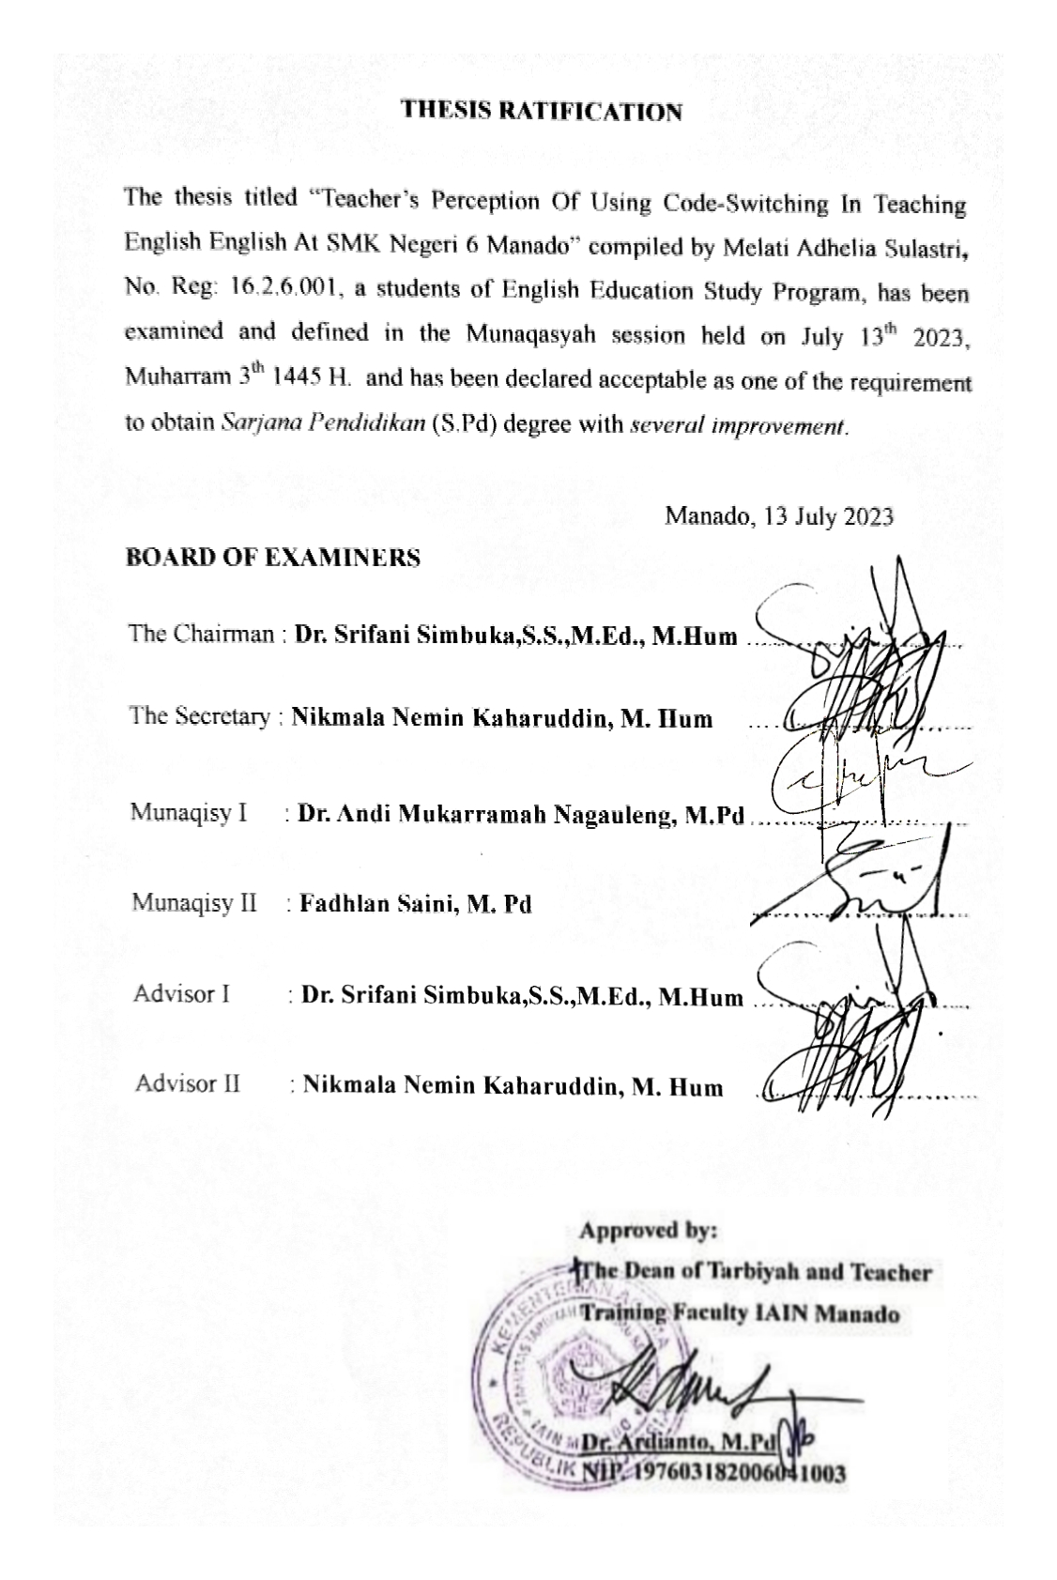
ACKNOWLEDGEMENT

Alhamdulillahi Rabbil Alamiin. First of all,thanks to Allah SWT, has for his mercy and guidance in giving the researcher full strength to finish this thesis.
Peace and salutation be upon our prophet Muhammad SAW, with his family and followers.
This thesis entitled “Teacher’s Perception Of Using Code-Switching In Teaching English English At SMK Negeri 6 Manado” is a cumpulsory completion of the strata 1 degree prerequisite. In finishing this thesis, the researcher got some problems and obstructions but the researcher received a lot of assistance from many people. The researcher’s deepest appreciation addresses to the researcher beloved parents Suparli Sambung and Indrawaty Ishak Pakaya (Rahimahullah), and the researcher’s husband Firmansyah Usman, and beloved sister Mutiara Prastuty Ningsih, S.Pd and brother Farez Syaif al-Fauzi Ibrahim. For the love, pray and support (May Allah SWT blessed them).
The reseacher would like to thank the Advisors. To my first advisor, Dr.Srifani Simbuka.,S.S.,M.Educ.,Stud.,M.Hum for the advice, and guidance from the very early stage of this research. Then to the second advisor, Nikmala Nemin Kaharuddin, M. Hum who has helped the researcher finishing this undergraduated thesis by giving suggestion,guidance and correction until the completion of this thesis.
Additionally,the researcher is grateful to the following for their supports and helps:
- Delmus Puneri Salim,S.Ag.,M.A.,M.Res.,Ph.D as the Rector of State Institute of Islamic Studies Manado.
- Dr. Ahmad Rajafi,M.Hi., as the first Deputy Rector of State Institute of Islamic Studies Manado.
- Dr. Radliyah Hasan Jan,S.E.,M.Si., as the second Deputy Rector of State Institute of Islamic Studies Manado.
- Dr. Musdalifah Dachrud, M.Si.,M,Psi as the Third Deputy Rector of State Institute of Islamic Studies Manado.
- Dr. Ardianto,M.Pd, as the Dean of Tarbiyah and Teacher Training of State Institute of Islamic Studies Manado.
- Dr. Mutmainah,M.Pd as the first Deputy Dean of the faculty of Tarbiyah and Teacher Training of State Institute of Islamic Studies Manado.
- Dr. Adri Lundeto,M.Pdi, as the second Deputy Dean of the faculty of Tarbiyah and Teacher Training of State Institute of Islamic Studies Manado.
- Dr. Feiby Ismail,M.Pd, as the third Deputy Dean of the faculty of Tarbiyah and Teacher Training of State Institute of Islamic Studies Manado.
- Nur Halimah, M.Hum, as the head of English Education Study Program of IAIN Manado.
- Dr. Andi Mukarramah Nagauleng,M.Pd as the first examiner who always motivates the researcher to complete this thesis.
- Fadhlan Saini, M.Pd as the second examiner who always motivates the researcher to complete this thesis.
- Fadhlan Saini, M.Pd as the secretary of English Education Study Program,giving motivation and support the researcher to completed this thesis.
- All lecturers in English Education Study Program of IAIN Manado who given Knowledge, Information, support and help for the researcher during the course or outside class.
- All the respondents in SMK Negeri 6 Manado who allowed the researcher to collect the data to completed this thesis.
- Dearest Friends who always support in any condition, Humaira Miftahul Jannah Haras, S.Pd, and Pipit Ayu Nirindah.

The researcher realizes that this thesis is still far from being perfect and hopes that this thesis would be useful for the next researcher or for readers in general.

Manado, 21 July 2023
The Researcher
Melati Adhelia Sulastri
NIM. 16.2.6.001

TABLE OF CONTENTS

COVER i
PERNYATAAN KEASLIAN SKRIPSI ii
RATIFICATION iii
ACKNOWLEDGEMENT iv
TABLE OF CONTENT vii
LIST OF TABLE ix
LIST OF APPENDICES
ABSTRACT

CHAPTER I INTRODUCTION 1
A. Research Background 1
B. Limitations and Research Questions 3
C. Objectives of the Study 3
D. Benefits of the Study 3
E. Definition of Key Terms 4

CHAPTER II THEORETICAL FOUNDATION 6
A. Concept of Perception 6
B. Code Switching 8
C. Previous Studies 14

CHAPTER III RESEARCH METHODOLOGY 18
A. Approach and Research Design 187
B. Researchers Presence 187
C. Research Location 19
D. Data and Source of Data 19
E. Data Collection Technique 19
F. Data Analysis Technique 20
G. Checking Validation of Data 21
H. Research Stages 21
REFERENCES 24
APPENDICES
BIOGRAPHY

LIST OF TABLES

4.1 Inter - Sentential Code-Switching 26
4.2 Intra - Sentential Code-Switching 27
4.3 Extra - Sentential Code-Switching 28

LIST OF APPENDICES

Appendix 1 Observation Sheets
Appendix 2 interview with English Teacher
Appendix 3 Documentation of Photograph

CHAPTER I
INTRODUCTION
- Research Background
Indonesia is one of the countries that make English as one of the languages taught in educational institutions. Of course, this is intended that students in Indonesia can master English so that they have basic capital in order to compete in the current era of globalization. Allah also says in the Qur'an surah Al-Hujurat/49: 13 about the following languages:
يَٰٓأَيُّهَا ٱلنَّاسُ إِنَّا خَلَقۡنَٰكُم مِّن ذَكَرٖ وَأُنثَىٰ وَجَعَلۡنَٰكُمۡ شُعُوبٗا وَقَبَآئِلَ لِتَعَارَفُوٓاْۚ إِنَّ أَكۡرَمَكُمۡ عِندَ ٱللَّهِ أَتۡقَىٰكُمۡۚ إِنَّ ٱللَّهَ عَلِيمٌ خَبِيرٞ
Meaning:

“O mankind, indeed We have created you from male and female and made you peoples and tribes that you may know one another. Indeed, the most noble of you in the sight of Allah is the most righteous of you. Indeed, Allah is Knowing and Acquainted.”

Through the above verse, we can see and know that the language of God's creation is so that everyone from different countries can communicate and interact well.

The communication aspect of a language is very important. Sholihatul Hamidah says that the function of language is to communicate thoughts directly to others. Linguistic studies reveal the relationship between language and society. It is interrelated and cannot be separated for research. Hence, the study of language and society developed into sociolinguistic to explain how languages can function in the society. One of the efforts made by English teachers in an educational institution is to apply strategies known as code mixing and Code Switching. Code switching is the skill of speaking two languages in a conversation. Code Mixing is the skill of speaking by mixing two languages in a sentence for example by borrowing a word from a foreign language which is then mixed with the initial language that is being spoken because it has become a habit.
The use of these two types of code is intended to improve students' speaking English. One example that is often used by English teachers is the use of Code Switching when starting learning, in the middle of learning, through to the end of learning.
Therefore, mastery of code switching provides great benefits at the time of learning. Based on this phenomenon, it is considered necessary to conduct scientific research on this topic through the perception of teachers who teach English in the classroom.

- Research Questions
Based on the description in the background, the main problem in this study is to find out the teachers perception of the use of code switching in English learning formulated in the following question:
- How do teachers use the type of Code Switching in English teaching?
- Limitations of The Research
The focus of this study is theoretically limited to the investigation of code-switching because code-mixing, the other language switching-mixing phenomena had been widely studied.
- Objectives of The Study
The purpose of the research is as follows:
- To find out teacher’s perception of using Code Switching in English learning.
- To find out the type of Code Switching that teacher use during the learning process.
- To find out the implication of using Code Switching in English Learning and Teaching.
- Benefits of the Study
- Theoretical Benefits
It is expected that the results of this study Provide an understanding of the use of Code Switching which is often used by English teachers. In addition, this study will enrich the literature on this topic in the ELT studies academic literature.

- Practical Benefit
This research is expected to be useful for teachers as a reference to evaluate the English learning process they carry out, especially on the use of Code Switching.
- Definition of Key Terms
The title of this thesis is “Teacher's Perception of Using Code Switching in Learning English at SMK Negeri 6 Manado”. Some of the terms or words that make up the title feel necessary to be explained so that there is no misinterpretation. To facilitate understanding of these terms, the author gives the term affirmation in the thesis title as follows:
- Perception
Perception implies quick and often sympathetic discernment (as of shades of feeling). In other senses perception is a psychological function that begins with a sensation, followed by some stimuli. The stimuli are accepted and grouped and then concluded in the subjective sense of an individual. Therefore perception is a person’s psychological ability to respondto a sensation that encourages that person to have a conclusion from what he feels.
- Teacher
Teachers are the central point of education. In formal education, teachers have three main tasks, namely planning learning before it begins, implementing the plan, and reciprocate from the learning. According to Sardiman quoted by Lilis that teachers are one of the human components in the teaching and learning process, which plays a role in the efforts to build potential human resources in the field of development.
- Code Switching
Code switching is a term in linguistics that refers to the use of more than one language or variety in a conversation. When the speaker has difficulty speaking with his interlocutor, she replaces his language with the language of the interlocutor so that it can be understood.

CHAPTER II
THEORETICAL FOUNDATION
- Concept of Perception
- Understanding perception
Language perception is the sight or response of the power of understanding or responding. Perception is the process of introducing, regulating, and generating stimuli to distinguish between two theories, each of which provides a higher sensation and thought process. Achmadi said perception is an active process to give legitimacy and rationalization to social behavior and relationships in society.
The existence of a perception because it is influenced by various factors, such as the consciousness of the individual soul, past experiences, knowledge, motivation and various social relationships. When a person produces a perception in himself, then that person has gone through various things starting from describing something, knowing it, detecting things that. So, simply this perception is a choice of opinions from various experiences experienced by a person.

- The Types of Perception
Perception is the process of how humans respond to an object. Human perception is difficult and complex because humans are dynamic. Perception of the physical environment is different from the perception of the social environment. This difference includes the following items:
- Perception of objects through physical symbols while perception of people through verbal and nonverbal symbols. Humans are more active than most objects and are harder to predict.
- Object perception responds to external nature while human perception responds to inner and outer nature. Most objects don't see us when we see objects. But people see us when we see them. In other words, human perception is more interactive.
- Things don't act, while humans react. In other words, objects are static while humans are dynamic. Therefore, human perception can change over time, faster than the perception of objects.
- The Factors that Affect Perception
Because perception is more psychological than the sensing process alone, there are several factors that affect:
- Selective attention
In human life when it will receive a lot of stimulation from its environment. However, he does not have to respond to all the stimulation he receives for it, the individual focuses his attention on certain excitatory only thus, other objects or symptoms will not appear to the face as objects of observation.
- Excitatory features
The stimulation that moves between silent excitation will attract more attention. Likewise, the greatest stimulation among the small; Which contrasts with its background and the intensity of its stimuli is strongest.
- Individual values and needs
An artist certainly has patterns and flavors that are in his observations rather than an artist. Research also shows that children from low economic brackets see bigger coins than the children of the rich.
So, perception is an ability of a person to pay attention, assess and give opinions to an event or object based on the experience that he can influence by some of the above factors.
- Code Switching
- Sociolinguistics
Sociolinguistics is an interdisciplinary science. The term himself shows that in consists of the fields of sociology and linguistics. In social-linguistic terms (sociolinguistics) the word socio is a major aspect of research and is common feature the field of science. Linguistics in this case is also social because language is also social, that is language and its structure are only can develop in a particular society. Code switching cannot be separated from sociolinguistics. This because code switching is part of a sociolinguistics phenomenon. Every human being uses language to interact with others in society anytime and anywhere. Edward Sapir stated that language is purely human for communicative purposes by a group of people who make up the language of society. People interact and communicate their opinions, talking about things using language, when they want to communicate in their activities.
- Understanding Code Switching
Code is a neutral term that can refer to a language, dialect, sociolect, or variety of languages. Code transfer according to Suwandi can occur in a conversation when a speaker uses a language and his or her interlocutor answers in another language. Furthermore, Saddhono explained that code mix is the use of two or more languages by inserting one language element into the other. In this case the speaker slips the elements of other languages when using a particular language.
According to Duran, code transfer may be very closely related to the life of the person and may appear more or less simultaneously in the lives of language students who are developing especially when they are aware of the behavior and then choose more or less intentionally to use or not to use. Based on the statement, code transfer is clearly a combination of two or more languages and could be appeared on the words, phrases, and sentences, or their the combination of each of them.
- Types of Code Switching
There are three types of switching codes according to Poplack namely Tag Switching, Inter-sentential Switching, and the last Intra-sentential Switching, as follows:
- Inter-sentential Switching
This type means a language diversion that occurs after a speaker completes the first sentence. In the next sentence, the speaker switches it to another language. So, switching is a stratified type of language transfer. Examples are as follows:
You have the task for the next meeting. Kamu harus membuat dialog pendek.

Kerjakan tugas bahas Inggris kemarin. Do you understand?

- Intra-sentential code switching
This type of code switching means a speaker switches the conversation to another language, but it's still in the same speech sentence. A speaker will enter a clause (child sentences) or phrase in a different language but still in the same sentence. For example:
Can you please tell me kalimat apa ini?

Open your book and kerjakan halaman 10!

- Tag or Extra-sentential Switching
Instead of discussing this type of meaning is that a speaker inserts a short expression into his expression in a different language at the end of the expression. For example:
Bagus, Good job Santi!

It's okay, no problem, ya nggak?

- Switching Languages in the Classroom
The use of two or more languages in a classroom provides great benefits when learning. The use of language transfer, will make communication between educators and students clear. Especially now there is an increase in foreign language learning in schools. This will certainly help, because not all students have the same language background as they were being taught in their classroom at the time. For example, learning English, of course, not all students are educated with English outside the school environment. So, it takes another language that needs to be used by educators when teaching, so that the intentions of the educator are conveyed.

- Teacher as Learning Designer
Basically, the learning process involves two parties, namely educators and learners. Each has their rights and obligations in the teaching and learning process. If described in more detail, then there are four parties in the learning process itself, namely those who seek to learn, those who are trying to learn, those who are the source of lessons, and interested parties to the results of the teaching and learning process.
The teacher itself is the main center in the learning process. The quality of a learning is determined by whether or not the teacher in planning or designing a learning process. According to Gentry quoted by Dewi that learning design is a process that formulates and determines learning goals, strategies, techniques, and media for general goals to be achieved. One of the general goals is that learning is not only able to transfer a new knowledge, but also able to transfer attitudes and values and skills to learners.
The essence of learning design refers to four core components, namely students, learning objectives, methods and assessments. Details of these components, namely:
- Learners
In the design of learning, then learners become one of the components that need to be considered. Physical fatigue, drowsiness, boredom or saturation that plagues learners can reduce concentration. Therefore, what needs to be done by learning designers is to plan a conducive learning so that learners feel comfortable and the goal of learning can be achieved.
- Learning Objectives
The purpose of learning in question is that the learning designer combines the needs of learners with competencies that must be mastered by them later after completion of learning with certain requirements and under predetermined conditions.
- Method
Methods are closely related to learning strategies that need to be designed so that the learning process runs smoothly. This method is the main key in the learning process, because it is closely related to the strategy of delivering material and the actual learning situation. Learning methods are also related to the media and time available for learning.
- Assessment
Assessment of learning outcomes becomes very important, because indicators of the success of achieving a learning goal can be observed from the assessment of learning outcomes.
In addition to learning design, a teacher is also required to have varied teaching skills such as: variations in teaching styles that include variations in the use of sound, concentration of attention, silence, making contact with perspective, movement of sight and mimicry; variations in the use of learning media, such as variations in the use of visual media, auditive media, and tactile media; variations in learning interaction patterns, both interaction between students and students, interaction between teachers and students.
- Previous Studies
This study is a study of previous research. This is done to avoid repeating previous research. Based on the search of existing research results, several previous studies found that are relevant to this study, including:
- Research from Rini Agustiana Nasution
An Analysis of Code Switching Between English and Indonesia Language in Teaching Process of Speech on the English Department Students at The State Islamic University North Sumatra. Findings from data analysis showed that this type of language switching was found in three types: inter-sentence redirection, intra-sentence redirection, and tag redirection. The language transfer function used by lecturers found three functions, namely topic transfer, affective function, repetition function. And the reason for the use of language switching is repetition used for clarification and interjection. The similarity with this research is the use of language diversion by a person who is central in learning. And the difference is the research subject is a lecturer while the researcher is a teacher.

- Research From Ahmad Mustamir Waris
Code Switching and Mixing (Communication in Learning language). The results show that in a learning, communication is one of the main and most important elements. The transfer and incorporation of languages in learning, especially foreign languages, is one of the tricks so that the learner can indirectly understand the language they are learning. Teacher’s code switching in the classroom to make clear meanings and to transfer knowledge to students in an efficient way. However, it should be remembered that in the long run, when students experience interaction with native speakers of a language; Code switching can be a barrier that prevents mutual understanding. The similarity with this research is we’re talking about language tranfer. And the difference is this study uses literature while researchers use qualitative.
- Research From Isnawati
This study comes from Isnawati with the title “The Analysis Of Code-Switching Used By Students In Small Group Discussion”. In her research discovered that the majority of students employ code-switching during small group discussions as a means to facilitate comprehension of ideas conveyed by the speaker and to promote seamless interaction amongst the participants. The similarity with this research are they both use the code-swiching method in the research process. And the difference is a previous studies have focused on students using the code-switching method in the research process. While recent research focuses on teacher perceptions during the research process.
- Research From Juliadnyana I. G., dkk
There have been 3 types of code switching utilized by the eighth grade English instructors in teaching system. There were intra sentential, inter sentential and inter personal code switching. primarily based at the accumulation, there have been 246 utterances produced by the English instructors, catagorized as code switching. In this example, seventy eight utterances had been categorised as intra sentensial code witching, one hundred and thirty 5 utterances as inter sentential code switching and thirty 3 utterances as inter personal code switching. Except that, students also had high-quality perception approximately the use of code switching in coaching process. The similarity with this research with thw latest research has similarities, namely both use the code-switching method. And the difference is previous studiesused student perceptions at the Junior High School level.
- Research From Murtafiah
In her study discovered that three types of Code-Switching can be observed: inter-sentential code-switching, intra-sentential code-switching, and tag-switching. English teachers were observed to utilize code-switching for three specific purposes: topic, affective fuction, and repetitive function. The similarity with the research is previous research and recent research both use code-switching, and also previous research and recent research are equally applied at the SMA/SMK equivalent level. And the difference is a previous research did not focus on teacher perceptions. Whereas recent research focuses on teacher perceptions.

CHAPTER III
RESEARCH METHODOLOGY
- Approach and Research Design
This type of research is qualitative research. Qualitative research is a research method used to express the deep meaning of a social phenomenon that is not easy to understand explicitly. Qualitative research is a research study that starts from a researcher's assumption or interpretation of a social problem faced by an individual or group that will be the focus of the research.
So, in this study the researcher tried to find answers to social phenomena that are being studied, then the author describes the various answers obtained and produces a meaning from the results of the study. In the study the researcher sought to gain a deep understanding of the perception of teachers as central to the use of education. Code switching in English learning is carried out while learning takes place.
- Researchers Instrument
In this qualitative study, researcher involved as key instruments in research. Researchers look for answers to the social experiences experienced by each individual, then gained meaning to the social phenomenon. Researcher engage in ongoing and continuous experiences with participants and identify and collate answers as results of research.
- Research Location
This research was conducted at SMK Negeri 6 Manado in the two months of June-July 2023.
- Data and Source of Data
Data is a number of information obtained from the research process so that it can support a research and produce a complete research.
Judging from the source, there are two sources of research data, namely:
- Primary Data
Primary data is a source of data directly obtained from research subjects using established instruments. For example, data obtained from observations, documentation and interviews directly to data sources, such as English teachers in the school studied.
- Data Collection Technique
In this study, researchers collected data using the following techniques:
- Interview
According to Esterberg quoted by Sugiono the interview is a meeting of two people to exchange information and ideas through Q&A, so that it can be constructed meaning in a particular topic. In this study, the researcher used semi-structured interview techniques. The use of semi-structured interviews in this study is so as not to be bound in questions that have been compiled, thus allowing researchers to dig more widely, and deeply as the interview progresses
- Data Analysis Technique
The data analysis techniques in this study are descriptive and holistic using three interconnected flows, namely data reduction, data display and drawing conclusions or verification. Reduction of data in this study, focusing on the process of selection, concentration, simplification, abstraction, and transforming data results of research. The second step is the presentation of data display by categorizing it by compiling a set of data based on certain mindsets, opinions, and criteria to draw conclusions. In this case, the researchers used a narrative text model, by pouring data through words instead of numbers. While the last step is the withdrawal of conclusions or verification of data, namely the withdrawal of conclusions based on the data that has been presented. This conclusion is presented by interpreting data based on the categories that have been created and connecting them so that they can be known in a complete, thorough, and comprehensive about teacher perception.
Then the provisional conclusion is retested its validity by looking at aspects of rationality, accuracy and objectives. This was done to obtain the final results in response to this study. Validity is one of the strengths of qualitative research and is based on determining whether the findings obtained are accurate from the point of view of researchers, participants, or.

- Checking Validation of Data
At this stage the researcher uses several stages to obtain the wetness of the data, namely:
- Triangulation
Triangulation is the checking of data from various sources, methods, and theories. At this stage the authors compare the perceptions of one person with another, comparing observational data, interviews, and theories found related to the study.
- Using Reference Materials
The point is the support to prove the data found by researchers during the research process. In addition, there are many references available, can test and correct the results of research that has been done. For example, photographs, interview recordings, and documentation.

- Research Stages
In qualitative approach, there were some stages done by the researcher. Bogdan presents three research stages they are preliminary research, research activity and intensive analysis. In this study, the researcher use some stages, they were:
- Preliminary Research
In the preliminary researcher formulated research title and research questions, examined related literatures, chose the research location based on the suitability of research questions, determined research subjects, and chose collecting data instruments. Preliminary study has been conducted from June 2023 to July 2023.
- Research Design
In the research design stage, the researcher did some activities, these were writing research proposal, decided research instruments, organized preliminary research, constructed research instruments, and prepared research activity. The research design was started from June 2023 to July 2023.
- Research Activity
In this study, the researcher needs some activities dealing with the description of research activity in the field. The activity was divided into three parts; they were.
- Identify reseach background
- Doing the research
- Collecting the data

- Data analysis and Interprotation
In the intensive analysis stage, the researcher discovered the theme
and analyzed it. The analysis was started on November 2021.
- Writing the Research Report
In this study, the researcher considered some aspects related to the writing of research report such as design the report, basic content of the report, parts of the complement and written system of the report. Based on these aspects, the researcher started writing the research report which followed the aspects such as the design of the study, the content of the study and other parts of the study.

CHAPTER IV
FINDINGS AND DISCUSSION

This chapter explains the general description of the research site, findings, discussion and the implication of this research. The findings presented the data collected from the observations and interview. The data were collected from the English teachers in (hence forward SMK Negeri 6 Manado).
A. Findings
- Result of Documentation
The researcher carried out documentation sheet, observation guideline, and the result of interview (See appendix).
- Result of observation
According to Jendra based on the level of code-switching language devices, the researcher found three forms of code-mixing it had getthere from observation. The data had been described into a specific group. The following is presented the types of Code-switching, tag or extra-sentential, inter-sentential, and intra-sentential.

a. Types of Code Switching
Inter – sentential switching: This type means a language diversion that occurs after a speaker completes the first sentence. In the next sentence, the speaker switches it to another language. So, switching is a stratified type of language transfer.
Intra – sentential switching: This type of code switching means a speaker switches the conversation to another language, but it’s still in the same speech sentence. A speaker will enter a clause (child sentences) or phrase in a different language but still in the same sentence.

Extra – sentential switching: Instead of discussing this type of meaning is that a speaker inserts a short expression into his expression in a different language at the end of the expression.

Table 4.1 Inter- Sentential switching

No. | Findings | The Informant of  Code-Switching
1. | Apa kabar anak- anak hari ini ? are you happy in this morning ? | Teacher 1 initial JA
2. | You know when I want to school yesterday. Ibu ada liat orang-orang pe rame skali di jalan, ada acara kota sto kang. | Teacher 2 initial MK
3. | Lots of ashes scattered. Tolong tutup itu pintu. | Teacher 3 initial SE
This table explain about the conversation between the teacher and student using Code-Switching in a class. The teacher used Inter- sentential switching. Such as from the first coloumn, the teachers said about hows students feeling in the morning with Bahasa and English In the next sentences after the first sentences was clear. And it same with the coloumn 2,3... etc.

Table 4.2 Intra- Sentential Switching

No. | Findings | The Informant of  Code-Switching
1. | Pergi temui Miftah, And give this key.. | Teacher 1 initial JA
2. | Open your book, Dan kerjakan halaman 25. | Teacher 2 initial MK
3. | Remove the dry leaves. Kong se kumpul jadi satu itu. | Teacher 3 initial SE

This table explain about the conversation with using Code-Switching in a class. The teacher using Intra- sentential switching. Such as from the first coloumn, the teachers said about command sentence with english and the otherwise. And it same with teacher 2 and 3.

Table 4.3 Extra - Sentential Switching

No. | Findings | The Informant of  Code-Switching
1. | Hei! Whatsup! | Teacher 1 initial JA
2. | Watch out! Nanti kamu kena hujan. | Teacher 2 initial MK
3. | Aduh! My finger caught in the door. | Teacher 3 initial SE

This table explain about the conversation using Code-Switching in a class. The teacher using Extra- sentential switching. Such as from the first coloumn, the teacher 1 said about short expressions. And it same with the teacher 2 and 3.

Result of Interview with Teacher
Question 1:
In your opinion, what makes it difficult for a student to be confident in learning English?
Answer:
Teacher I: I think the students have a lack of vocabulary, so they can’t speak english well. And it some difficulties things for them.
Teacher II: I think because they dont have a support system for learning english from childhood.
Teacher III: Maybe because they not learn more from their childhood.

Question 2
Why you ever allowed students to do code-switching in class?
Answer:
Teacher I: Yaaaa because we live in manado yang notabenenya masih kurang for mo full english, so i allowed them to using Code-Switching all the time in learning process.
Teacher II: So they can understand satu sama lain deng depe teman teman tentang materi dikelas.
Teacher III: So they can faster to clear their material that i give.

Question 3
In your opinion. What is the impact for student to do code-switching?

Answer:
Teacher I: Nah seperti yang kita katakan tadi, deng if them used full english they will not understand what they said with the friends. Deng depe susunan kata not compatible with apa yang dia mo bicarakan.
Teacher II: They can feel more confident to speak and they can added their vocabs to be yaaa more confident lagi.
Teacher III: Agar katu dorang ndak kaku pas belajar bahasa inggris. Karena they can using Code-Switching.

Question 4
When you allow them to code-switching?
Answer:
Teacher I: All the time in learning process no tentunya.
Teacher II: In learning process when they stuck on some sentences. They can used Code Switching.
Teacher III: Kita kase katu noh kalo dorang rasa ndak mampu wona mo bagimana dang ?mar katu ja lia lia noh kalo masih boleh kadang reen ta ja marah.

Question 5
Why you think students will be more confident to learn using code-switching?
Answer:
Teacher I: Because their afraid if using full english dan jatohnya ndak mo mangarti deng ndak mo PD atau percaya diri no.
Teacher II: They can understand what they said with ta pasdeng dorang pe tamang.
Teacher III: Because Code Switching make them understand about what they said.

B. Discussions

This research focuses on the types of the Code-Switching used by teachers in classroom disscussions process at classroom. To made disscussion clear, the researchers would like to describe the result of data analyzed as follow :
Types of Code-Switching
Based on the findings there were 3 types of Code- Switching used by students in classroom disscussions process in the classroom. Those types are Inter-Sentential Switching, Intra- Sentential Switching, and Extra-Sentential Switching.
- Inter-Sentential Switching
The first type called inter-sentential switching. It shown in the table 4.1. The teacher switched language from English to Manado or the otherwise, as Jack and Richard (2002) stated that Code-Switching is a change by a Speaker from one language to another language.
- Intra-Sentential Swiching
The second types is called intra sentential code switching. It is shown in the table 4.2. The teacher switched from English to Manado and or the otherwise. That has same meaning each other. As Von (2004) stated the code switching is a phenomenon of language contact that is generally defined as the alternative use of two or more languages usually marked by a clear break between the language.
- Extra- Sentential Switching
The third types is called Extra Sentential Switching. According to Poplack in Hamers and Blanc (2004), this types of Code-Switching involves the insertion of attack for one language into a clause or sentence in a different language. It shown in the table 4.3. The students used extra sentential switching in beginning in the middle and the end of their opinion while on the classroom disscussions.

CHAPTER V
CONCLUSION AND SUGGESTION

- Conclusion

The researcher finds out 3 Types of Code Switching in Teaching English that are Inter-Sentential Swiching, Intra-Sentential Switching, And Extra- Sentential Switching. In this research, The researcher found in the Teaching English Dominates used Code- Switching is the Teacher.

- Suggestions
Based on the result of this research, The Researcher will suggest :
- This research is suggested to teacher to do Code- Switching in teaching English.
- By using code switching in Teaching English, teachers are adviced to do Code-Switching in Teaching English on the classroom.

REFERENCES

Annisa Dwi Pujiyati, “Kedudukan Bahasa Indonesia Dan Bahasa Inggris Sebagai
Penghela Ilmu Pengetahuan Di Era Globalisasi (Position of Indonesian and English Languange as A Developer of Knowledge Science in The Era of Globalization),” Jurnal Bahasa Indonesia FKIP Universitas Sebelas Maret Surakarta (2019).

Imam Suyuthi dalam Kitab Tafsir AlQuran dan Tejermahannya, Al-Durr Al-
Mantsur fi Tafsir Bil-Ma’tsur.

Sholihatul Hamidah, Pengantar Linguistik Umum (Medan: La-Tansa Press, 2011).

Fithrah Auliya Ansar, “Code Switching and Code Mixing in Teaching-Learning
Process,” English Education: Jurnal Tadris Bahasa Inggris 10, no. 1 (April 11, 2017): 31.

Merriam Webster, Dictionary Perception https://merriam-webster.com/dictionary/perception (26 Januari 2023).

Anugrah, “Teacher’s Perception on The Use of Authentic Materials to Teach
Listening” (Tesis S2, Fakultas Pendidikan dan Keguruan Universitas Muhammadiyah Makassar, 2019),.

Hendra, “Peran Guru Dalam Meningkatkan Motivasi Belajar Siswa Pada Mata
Pelajaran Sosiologi Kelas XI Di SMA Laboratorium Malang” (Skripsi S1, Fakultas Ilmu Tarbiyah dan Keguruan UIN Maulana Malik Ibrahim Malang, 2017),.

A. M. Sardiman, Interaksi Dan Motivasi Belajar Mengajar, Cet. 24. (Jakarta: PT
Raja Grafindo Persada, 2018)

Ahmad Mustamir Waris, “Code Switching and Mixing (Communication in
Learning Languange),” Jurnal Dakwah Tabligh 13, no. 1 (2012): 125.

Echols and Shadily, Kamus Inggris Indonesia: An English-Indonesian Dictionary,.

Anugrah, “Teacher’s Perception on The Use of Authentic Materials to Teach Listening,”.

Achmadi, Ideologi Pendidikan Islam: Paradigma Humanisme Teosentris
(Yogyakarta: Pustaka Pelajar, 2005).

Sayama Malabar, Sociolinguistics (Gorontalo: Sociolinguistics), p.

Hanifah Nabighah Kultsum, John Edward, Language and Identity (Amerika
Serikat: Cambridge University Press, 2009),

Suamarsono and Paina Partana, Sosiolinguistik (Yogyakarta: Sabda, 2004), .

Sarwiji Suwandi, Serba Linguistik: Mengupas Pelbagai Praktik Bahasa
(Surakarta: Universitas Sebelas Maret Press, 2010),

Kundharu Saddhono, Pengantar Sosiolinguistik: Teori Dan Konsep Dasar
(Surakarta: Universitas Sebelas Maret Press, 2012),.

Sumarsih et al., “Switching and Code Mixing in Indonesian,” Study in
Sociolinguistics 4, no. 1 (2014), .

Waris, “Code Switching and Mixing (Communication in Learning Languange),”.

Ansar, “Code Switching and Code Mixing in Teaching-Learning Process,”.

Rini Agustiana Nasution, “An Analysis of Code Switching Between English and
Indonesia Languange in Teaching Process of Speech on the English Department Students at The State Islamic University North Sumatera” (Skripsi S1, Fakultas Tarbiyah dan Ilmu Keguruan UIN Sumatera Utara, 2018),.

Imam Musbikin, Guru Yang Menakjubkan (Yogyakarta: Buku Biru, 2010), .

Dewi Salma Prawiradilaga, Prinsip Desain Pembelajaran (Jakarta: Kencana, 2009), .

Musbikin, Guru Yang Menakjubkan,.
Prawiradilaga, Prinsip Desain Pembelajaran, .

Mulyadi, Classroom Management Mewujudkan Suasana Kelas Yang
Menyenangkan Bagi Siswa (Malang: UIN Malik Press, 2009),.
Rini Agustiana Nasution, “An Analysis of Code Switching Between English and Indonesia Languange in Teaching Process of Speech on the English Department Students at The State Islamic University North Sumatera” (Skripsi S1, Fakultas Tarbiyah dan Ilmu Keguruan UIN Sumatera Utara, 2018).
Ahmad Mustamir Waris, “Code Switching and Mixing (Communication in Learning Languange),” Jurnal Dakwah Tabligh 13, no. 1 (2012): 123-135.
Isnawati, “The Analysis Of Code-Switching Used By Students In Small Group
Discussion” (Skripsi S1, Fakultas tarbiyah dan Ilmu Keguruan Universtas Muhammadiyah Makassar, 2019)

Juliadnyana, I. G, “The Analysis Of Teacher’s Code-Switching Based On The
Perceptions of The Eight Grade Students Of SMPN 2 Sawan. Singaraja” (Skripsi S1, Ganesha University Of Education, 2017 )

Eliya Murtafiah, “An Analysis Of Teachers’ Code-Switching Practice In The
Process Of Teaching English At SMAN 2 Padang Cermin In The Academic Year Of 2016 / 2017” (Skripsi S1, Fakultas Tarbiyah dan Ilmu Keguruan UIN Raden Intan Lampung, 2017).

Burhan Bungin, Penelitian Kualitatif Komunikasi, Ekonomi, Kebijakan Publik,
Dan Ilmu Sosial Lainnya, Edisi Kedua. (Jakarta: Kencana, 2017), p. 53.

John W. Creswell, Penelitian Kualitatif Dan Desain Riset: Memilih Di Antara
Lima Pendekatan, Terj. Oleh Ahmad Lintang Lazuardi. (Yogyakarta: Pustaka Pelajar, 2015), p. 87-88.

Norman K. Denzin and Yvonna S. Lincoln, Handbook of Qualitative Research,
Terj. oleh Dariyatno, dkk. (Yogyakarta: Pustaka Pelajar, 2009), p. 6.

John W. Creswell, Research Design: Qualitative, Quantitative, and Mixed
Methods Approaches, 4th edition, International Student Edition.
(Washington: SAGE, 2014), p. 264.

Sugiyono, Metode Penelitian Kuantitatif, Kualitatif, Dan R & D (Bandung:
Alfabeta, 2017), p. 225.

Sugiyono, Metode Penelitian Kuantitatif, Kualitatif, Dan R & D, p. 225.

Matthew B. Miles and Michael Huberman, Analisis Data Kualitatif (Jakarta: UI
Press, 1992), p. 17–19.

Muhajirin and Maya Panorama, Pendekatan Praktis Metode Penelitian Kualitatif
Dan Kuantitatif (Yogyakarta: Idea Press Yogyakarta, 2017), p. 274-275.

Creswell, Research Design: Qualitative, Quantitative, and Mixed Methods
Approaches, p. 268-273.

Lexy J. Moleong, Metodologi Penelitian Kualitatif Edisi Revisi, 33rd ed.
(Yogyakarta: PT Remaja Rosadakarya, 2014), p. 84.

APPENDIX

Appendix 1 Observation Sheets

Observation sheets

Instruments : Observation Sheets checklist
Date : 6 July 2023
Grade : English Teachers at SMK NEGERI 6 MANADO
NO | Activities | Yes | No | Descriptions
1. | The teacher introduce the topic before start teaching. |  |  | Jadi sebelum torang mulai, i would like to tell you about our topics “Agree and Disagree” sesuai yang sir so bilang lalu.
2. | The teacher gives an explanation the material until finish. |  |  | Time’s lack
3. | The teacher tells the procedure of learning English material to the students. |  |  | Kong torang hari ini mo terbagi atas 2 kelompok jo. Supaya nda too much nanti pas group disscussion
4. | The teacher makes a group of students in learning English activity. |  |  | Lets stand up!!!  Bagi jo dua kelompok neh kong nanti kelompok Right Side bagian Agree, yang Left Side bagian Disagree.
5. | The teacher uses Indonesian language and English to explain the materials. |  |  | So, the Righ Side should watch the video and give your suggestions as your Agree pride. And the left side, jelaskan sebagai Disagree neh.
6. | The teacher always uses English in teaching speaking. |  |  | Teacher always using Code-Switching in Learning.
7. | The teachers use of code-switching.  - Inter-Sentential Switching  - Intra-Sentential Switching  - Extra-Sentential Switching |  |  | In the learning process, teacher always used Code Switching and always using the three types of Code Switching.

Appendix 2 interview with English Teacher
Interview with English Teacher with initial JK

Questions | Answer
In your opinion, what makes it difficult for a student to be confident in learning English? | I think the students have a lack of vocabulary, so they can’t speak english well. And it some difficulties things for them.
Why you ever allowed students to do code-switching in class? | Yaaaa because we live in manado yang notabenenya masih kurang for mo full english, so i allowed them to using Code-Switching all the time in learning process.
In your opinion. What is the impact for student to do code-switching? | Nah seperti yang kita katakan tadi, deng if them used full english they will not understand what they said with the friends. Deng depe susunan kata not compatible with apa yang dia mo bicarakan.
When you allow them to code-switching? | All the time in learning process no tentunya.
Why you think students will be more confident to learn using code-switching? | Because their afraid if using full english dan jatohnya ndak mo mangarti deng ndak mo PD atau percaya diri no.

Interview with English Teacher with initial SE
Questions | Answer
In your opinion, what makes it difficult for a student to be confident in learning English? | I think because they dont have a support system for learning english from childhood.
Why you ever allowed students to do code-switching in class? | So they can understand satu sama lain deng depe teman teman tentang materi dikelas.
In your opinion. What is the impact for student to do code-switching? | They can feel more confident to speak and they can added their vocabs to be yaaa more confident lagi.
When you allow them to code-switching? | In learning process when they stuck on some sentences. They can used Code Switching.
Why you think students will be more confident to learn using code-switching? | They can understand what they said with ta pasdeng dorang pe tamang.

Interview with English Teacher with initial MK
Questions | Answer
In your opinion, what makes it difficult for a student to be confident in learning English? | Maybe because they not learn more from their childhood.
Why you ever allowed students to do code-switching in class? | So they can faster to clear their material that i give.
In your opinion. What is the impact for student to do code-switching? | Agar katu dorang ndak kaku pas belajar bahasa inggris. Karena they can using Code-Switching.
When you allow them to code-switching? | Kita kase katu noh kalo dorang rasa ndak mampu wona mo bagimana dang ?mar katu ja lia lia noh kalo masih boleh kadang reen ta ja marah.
Why you think students will be more confident to learn using code-switching? | Because Code Switching make them understand about what they said.

Appendix 3 Documentation of Photograph
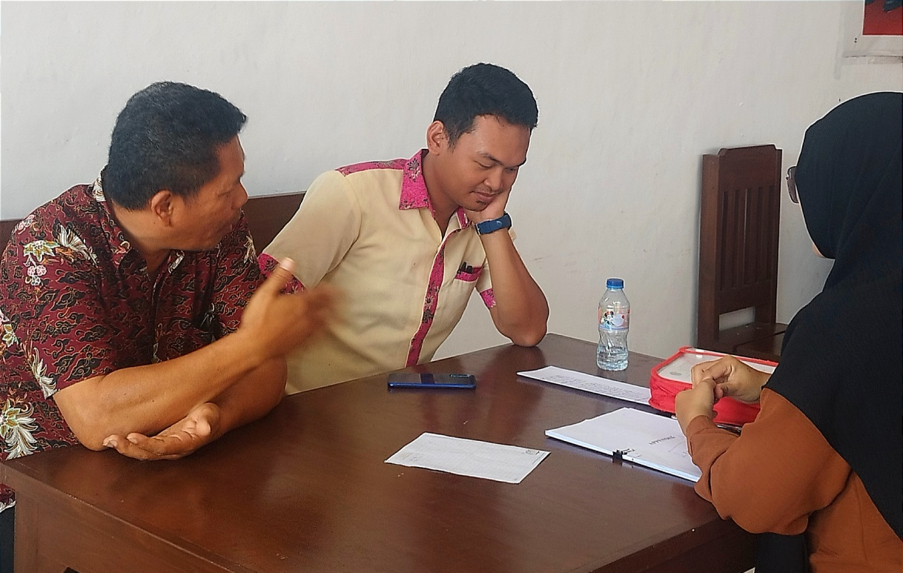
Interview with English teacher at SMK Negeri 6 Manado
(Mr. Jeki Maxi Agonta, S.Pd & Mr. Viki, S.Pd)
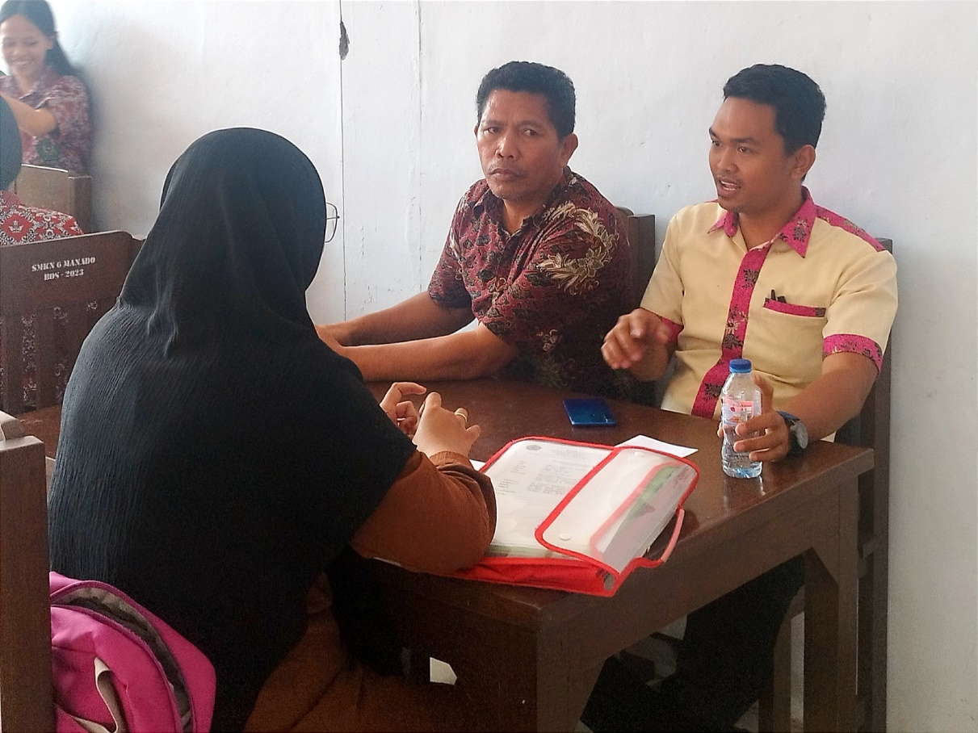
BIODATA PENULIS
Nama : Melati Adhelia Sulastri
Tempat dan Tanggal Lahir : Manado, 08 September 1998
Alamat : Dendengan Dalam, Lingkungan 3 Jl. Bahari 10, No: 58 Kampung Merdeka. Kec. Paal Dua, Kota Manado, Sulawesi Utara.
Nomor HP : 0899-0317-410
E-mail : melatiadeliart@gmail.com
Nama Orang Tua
Bapak : Suparli Sambung
Ibu : Indrawaty Ishak Pakaya
Suami/Istri : Firmansyah Usman
Riwayat Pendidikan
SD : SD Negeri 16 Manado (2004-2010)
SMP : SMP Negeri 1 Manado (2010-2013)
SMA : SMA Negeri 7 Manado (2013-2016)

Manado, 21 July 2023
Peneliti
Melati Adhelia Sulastri

Annisa Dwi Pujiyati, “Kedudukan Bahasa Indonesia Dan Bahasa Inggris Sebagai Penghela Ilmu Pengetahuan Di Era Globalisasi (Position of Indonesian and English Languange as A Developer of Knowledge Science in The Era of Globalization),” Jurnal Bahasa Indonesia FKIP Universitas Sebelas Maret Surakarta (2019): 6.
Imam Suyuthi dalam Kitab Tafsir AlQuran dan Tejermahannya, Al-Durr Al-Mantsur fi Tafsir Bil-Ma’tsur.
Sholihatul Hamidah, Pengantar Linguistik Umum (Medan: La-Tansa Press, 2011), p. 11.
Fithrah Auliya Ansar, “Code Switching and Code Mixing in Teaching-Learning Process,” English Education: Jurnal Tadris Bahasa Inggris 10, no. 1 (April 11, 2017): 31.
Merriam Webster, Dictionary Perception https://merriam-webster.com/dictionary/perception (26 Januari 2023).
Anugrah, “Teacher’s Perception on The Use of Authentic Materials to Teach Listening” (Tesis S2, Fakultas Pendidikan dan Keguruan Universitas Muhammadiyah Makassar, 2019), p. 8.
Hendra, “Peran Guru Dalam Meningkatkan Motivasi Belajar Siswa Pada Mata Pelajaran Sosiologi Kelas XI Di SMA Laboratorium Malang” (Skripsi S1, Fakultas Ilmu Tarbiyah dan Keguruan UIN Maulana Malik Ibrahim Malang, 2017), p. 12.
A. M. Sardiman, Interaksi Dan Motivasi Belajar Mengajar, Cet. 24. (Jakarta: PT Raja Grafindo Persada, 2018), p. 15
Ahmad Mustamir Waris, “Code Switching and Mixing (Communication in Learning Languange),” Jurnal Dakwah Tabligh 13, no. 1 (2012): 125.
Echols and Shadily, Kamus Inggris Indonesia: An English-Indonesian Dictionary, p. 424.
Anugrah, “Teacher’s Perception on The Use of Authentic Materials to Teach Listening,” p. 8.
Achmadi, Ideologi Pendidikan Islam: Paradigma Humanisme Teosentris (Yogyakarta: Pustaka Pelajar, 2005), p. 19.
Sayama Malabar, Sociolinguistics (Gorontalo: Sociolinguistics), p. 3.
Hanifah Nabighah Kultsum,
John Edward, Language and Identity (Amerika Serikat: Cambridge University Press, 2009), p. 53.
Suamarsono and Paina Partana, Sosiolinguistik (Yogyakarta: Sabda, 2004), p. 201.
Sarwiji Suwandi, Serba Linguistik: Mengupas Pelbagai Praktik Bahasa (Surakarta: Universitas Sebelas Maret Press, 2010), p. 86
Kundharu Saddhono, Pengantar Sosiolinguistik: Teori Dan Konsep Dasar (Surakarta: Universitas Sebelas Maret Press, 2012), p. 75.
Sumarsih et al., “Switching and Code Mixing in Indonesian,” Study in Sociolinguistics 4, no. 1 (2014), p. 77.
Waris, “Code Switching and Mixing (Communication in Learning Languange),” p. 125.
Ansar, “Code Switching and Code Mixing in Teaching-Learning Process,” p. 33.
Rini Agustiana Nasution, “An Analysis of Code Switching Between English and Indonesia Languange in Teaching Process of Speech on the English Department Students at The State Islamic University North Sumatera” (Skripsi S1, Fakultas Tarbiyah dan Ilmu Keguruan UIN Sumatera Utara, 2018), p. 16.
Imam Musbikin, Guru Yang Menakjubkan (Yogyakarta: Buku Biru, 2010), p. 258.
Dewi Salma Prawiradilaga, Prinsip Desain Pembelajaran (Jakarta: Kencana, 2009), p. 16.
Musbikin, Guru Yang Menakjubkan, p. 258.
Prawiradilaga, Prinsip Desain Pembelajaran, p. 17-18.
Mulyadi, Classroom Management Mewujudkan Suasana Kelas Yang Menyenangkan Bagi Siswa (Malang: UIN Malik Press, 2009), p. 7.
Rini Agustiana Nasution, “An Analysis of Code Switching Between English and Indonesia Languange in Teaching Process of Speech on the English Department Students at The State Islamic University North Sumatera” (Skripsi S1, Fakultas Tarbiyah dan Ilmu Keguruan UIN Sumatera Utara, 2018).
Ahmad Mustamir Waris, “Code Switching and Mixing (Communication in Learning Languange),” Jurnal Dakwah Tabligh 13, no. 1 (2012): 123-135.
Isnawati, “The Analysis Of Code-Switching Used By Students In Small Group Discussion” (Skripsi S1, Fakultas tarbiyah dan Ilmu Keguruan Universtas Muhammadiyah Makassar, 2019)
Juliadnyana, I. G, “The Analysis Of Teacher’s Code-Switching Based On The Perceptions of The Eight Grade Students Of SMPN 2 Sawan. Singaraja” (Skripsi S1, Ganesha University Of Education, 2017 )
Eliya Murtafiah, “An Analysis Of Teachers’ Code-Switching Practice In The Process Of Teaching English At SMAN 2 Padang Cermin In The Academic Year Of 2016 / 2017” (Skripsi S1, Fakultas Tarbiyah dan Ilmu Keguruan UIN Raden Intan Lampung, 2017).
Burhan Bungin, Penelitian Kualitatif Komunikasi, Ekonomi, Kebijakan Publik, Dan Ilmu Sosial Lainnya, Edisi Kedua. (Jakarta: Kencana, 2017), p. 53.
John W. Creswell, Penelitian Kualitatif Dan Desain Riset: Memilih Di Antara Lima Pendekatan, Terj. Oleh Ahmad Lintang Lazuardi. (Yogyakarta: Pustaka Pelajar, 2015), p. 87-88.
Norman K. Denzin and Yvonna S. Lincoln, Handbook of Qualitative Research, Terj. oleh Dariyatno, dkk. (Yogyakarta: Pustaka Pelajar, 2009), p. 6.
John W. Creswell, Research Design: Qualitative, Quantitative, and Mixed Methods Approaches, 4th edition, International Student Edition. (Washington: SAGE, 2014), p. 264.
Sugiyono, Metode Penelitian Kuantitatif, Kualitatif, Dan R & D (Bandung: Alfabeta, 2017), p. 225.
Sugiyono, Metode Penelitian Kuantitatif, Kualitatif, Dan R & D, p. 225.
Matthew B. Miles and Michael Huberman, Analisis Data Kualitatif (Jakarta: UI Press, 1992), p. 17–19.
Muhajirin and Maya Panorama, Pendekatan Praktis Metode Penelitian Kualitatif Dan Kuantitatif (Yogyakarta: Idea Press Yogyakarta, 2017), p. 274-275.
Creswell, Research Design: Qualitative, Quantitative, and Mixed Methods Approaches, p. 268-273.
Creswell, Research Design: Qualitative, Quantitative, and Mixed Methods Approaches, p. 264.
Creswell, Research Design: Qualitative, Quantitative, and Mixed Methods Approaches, 267.
Lexy J. Moleong, Metodologi Penelitian Kualitatif Edisi Revisi, 33rd ed. (Yogyakarta: PT Remaja Rosadakarya, 2014), p. 84.
Jendra, I `Wayan. “Dasar-Dasar Sosiolinguistik.” Denpasar: Ikayana (1991).
Waris, “Code Switching and Mixing (Communication in Learning Languange),” p. 125.
Ansar, “Code Switching and Code Mixing in Teaching-Learning Process,” p. 33.
Rini Agustiana Nasution, “An Analysis of Code Switching Between English and Indonesia Languange in Teaching Process of Speech on the English Department Students at The State Islamic University North Sumatera” (Skripsi S1, Fakultas Tarbiyah dan Ilmu Keguruan UIN Sumatera Utara, 2018), p. 16.

